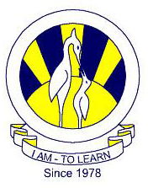
The City School
North Nazimabad Boys Campus
Worksheet#1
Biology class 9
Date: 11-06-2016
Teacher: Uzma Amer

Q.1.choose the best answers:
I
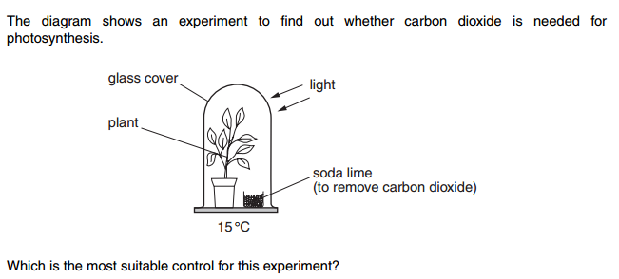

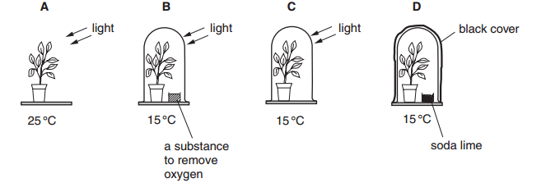

The blood component that carries oxygen is
- Red blood cells
- White blood cells.
- Plasma
- Platelets
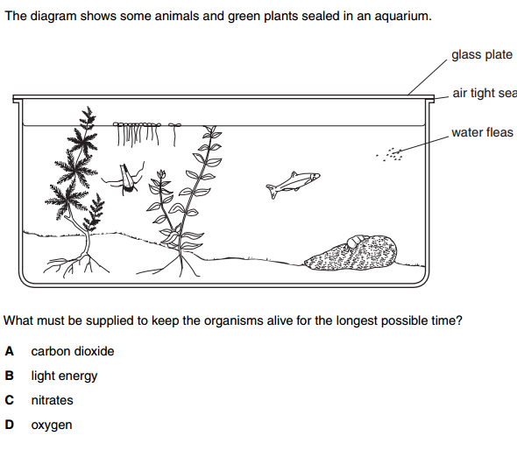

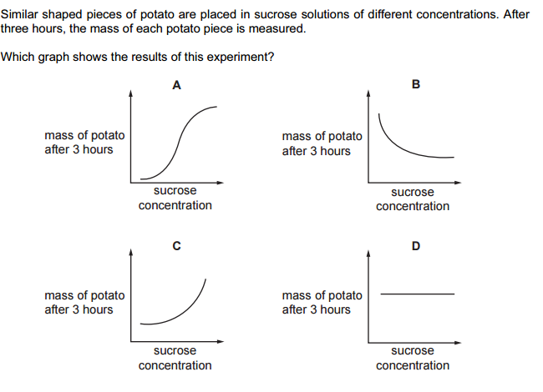

Q.2.State the food groups and describe the composition and functions of carbohydrates.

