The City School
North Nazimabad Boys Campus
Worksheet#1
Chemistry class 9
Date: 11-06-2016
Teacher: Uzma Amer

Q.1 (a) Define the following terms:
- Kinetic Energy
- Relative molecular mass
- Electron negativity
- Ionizing Energy
(b).calculate the Relative molecular masses of the given compounds:
- A compound XCl having molecular mass (Mr) of 58.5.Find out Mr of XCO3.
- A compound X2O having molecular mass (Mr) of 62 Find out Mr of X2SO4
- A compound XCl2 having molecular mass (Mr) of 111.Find out Mr of X(NO3)2
Q.3.Look at following diagrams and answers the questions given below:
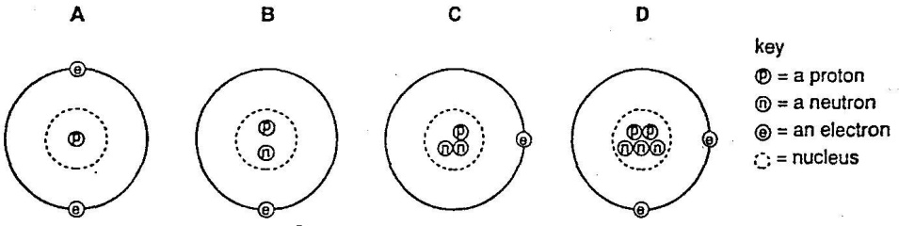
- Which atom has a mass of 5?
- Which atoms are isotopes of each other?
- What is the charge on above atoms?
- Explain your answer of part c.

