The City School
North Nazimabad Boys Campus
Grade 9 History
Worksheet
Q1. With reference to War of Independence 1857-58, answer the given questions.
Source A

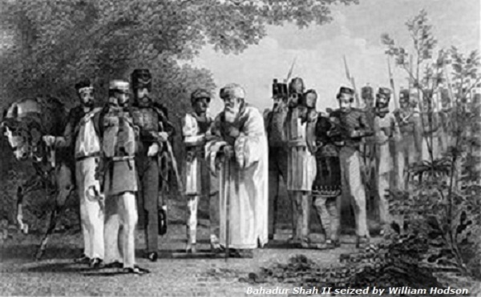
Indian Mutiny 1857-58

- According to the Source A, what was the aftermath of the War of Independence?[3]
- What was the Doctrine of lapse? [4]
- Who was Mangal Pandey? [4]
- What happened at Cawnpore in 1857-58? [4]
- What were the causes of war of independence? [7]
- “The strength of the British army was the sole reason for the failure of the War of Independence by 1858.” Do you agree? Give reasons for your answer. [10]

