The City School
North Nazimabad Boys Campus
Grade 9 History worksheet
Source A (i)
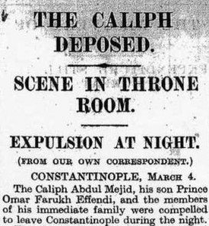
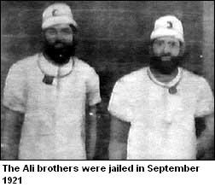
Source A (ii)

- According to the source A (i), why the Khilafat Movement declined? [3]
- According to the source A (ii), what was their role and contribution in the subcontinent?
- What was treaty of Versailles? [4]
- What was the treaty of Serves? [4]
- Why did the Khilafat Movement emerge? [7]
- “The given source A from a newspaper of 1922 is the most important reason for the failure of the movement that was going on in that era”. Discuss with appropriate references. [10]

