The City School

**North Nazimabad Boys Campus**

**Second Monthly Test Session 2019 – 20**

**Class - 11**

**Time: 35 Minutes Biology Marks 20**

**Name: ___________________ Sec: ______ Date: ______________**

**Q.1** Define the following terms: (5)

(i) Population (ii) community (iii) Ecosystem (iv) Ecological niche (v) Species

__________________________________________________________________________________________________________________________________________________________________________________________________________________________________________________________________________________________________________________________________________________________________________________________________________________________________________________________________________________________________________________________________________________________________________________________________________________________________________________________________________________

**Q.2** Draw pyramids of numbers, biomass and energy of the following food chain: (6)

Green algae→ mosquito larvae→ small fish→ carnivorous fish

The diagram shows a food web of fresh water ecosystem 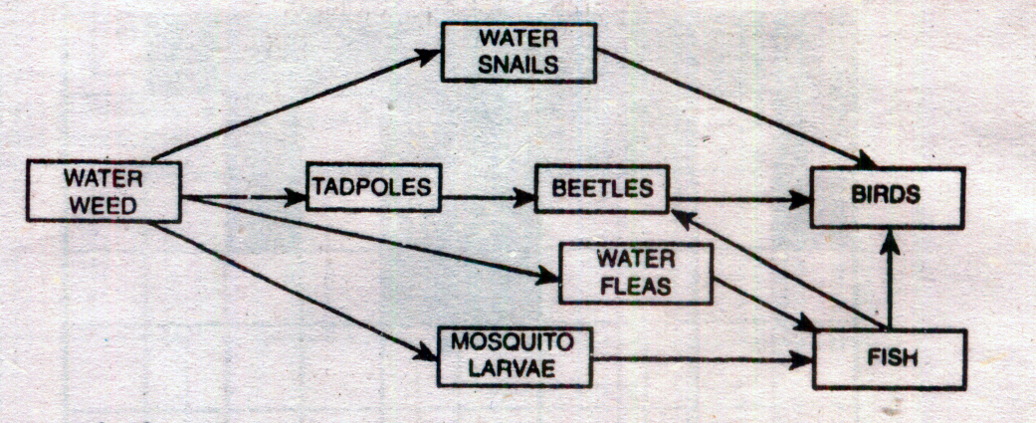

**Q.3** (i)Name one primary consumer and one secondary consumer in the food web. (1) ____________________________________________________________________________________________________________________________________________________________________________________________

(ii)Name the organism which is of vital importance in keeping other members of the web alive. Explain your answer. (2)

__________________________________________________________________________________________________________________________________________________________________________________________________________________________________________________________________________________________

Q.4 State the difference between scavengers and decomposers. (2)

________________________________________________________________________________________________________________________________________________________________________________________________________________________________________________________________________________________________________________________________________________________________________________________

The diagram shows part of the carbon cycle.



**Q.4** What are the processes X and Y? (2)

__________________________________________________________________________________________________________________________________________________________________________

The diagram shows some structures, Q, on the roots of a bean plant



.**Q.5** Which chemical change fixes nitrogen in these structures? (1)

**Q.6** Name the structure **Q** (1)

**_____________________________________________________________________________________**