The City School
North Nazimabad Boys Campus
Second Monthly Test Session 2019 – 20
Class - 9
Time: 35 Minutes Biology Marks 25
Name: ___________________ Sec: ______ Date: ______________
Q.1.Choose the best answers: [5]
- The general mechanism is that an enzyme acts by
- reducing the energy of activation
- increasing the energy of activation
- decreasing the pH
- increasing the pH
- The enzyme is
- Often a metal
- Always a protein
- often a vitamin
- always an inorganic compound
- The enzyme which hydrolyses starch to maltose is
- Protease
- Amylase
- Lipase
- Maltase
- The “lock and key” model of enzyme action illustrates that a particular enzyme molecule
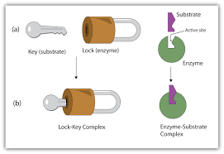
- forms a permanent enzyme-substrate complex
- may be destroyed and resynthesized several times
- interacts with a specific type of substrate molecule
- reacts at identical rates under all conditions

- An enzyme is generally named by adding ________ to the end of the name of the ___________.
- "-ase". coenzyme
- "-ase". cell in which it is found
- "-ose". substrate .
- "-ase". substrate

Q.2.The given figure shows, in order, four stages in which an enzyme-controlled chemical reaction may occur. M O P
N
- Identify M, N, O and P. [4]
M........................................................................ N...............................................................
O......................................................................... P...............................................................
(b) By referring to Fig explain why only a small amount of enzyme is needed to catalyze a reaction involving many molecules. [2]
……………………………………………………………………………………………………………………………………………………………
……………………………………………………………………………………………………………………………………………………………
(c) Enzymes show different rate of reaction at different temperatures.
(I) Explain how a rise in temperature may increase the rate of an enzyme-controlled reaction? [2]
…………………………………………………………………………………………………………………………………………………………………………………………………………………………………………………………………………………………………………………………
(ii) At high temperatures, enzymes are denatured and can no longer act as catalysts. By using the letters M and N from Fig suggest what happens when an enzyme is denatured. ? [2]
…………………………………………………………………………………………………………………………………………………………………………………………………………………………………………………………………………………………………………………………………………………………………………………………………………………………………………………………………………………………………………………………………………………………………………………………………………………………………………………….
Q.3.The graph shows a chemical (respiration) in the body:
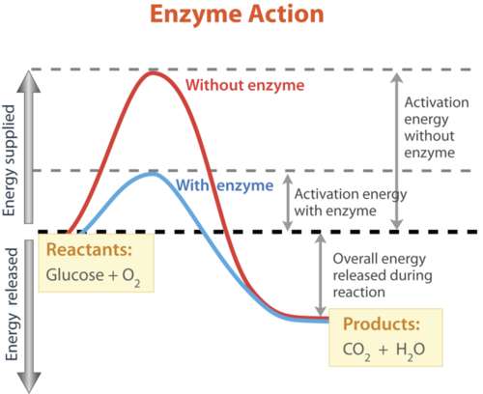

- Define activation energy. [2]
…………………………………………………………………………………………………………………………………………………………………………………………………………………………………………………………………………………………………………………………………………………………………………………………………………………………………………..….
- Why more activation energy is required when reaction takes place without enzymes? [3]
………………………………………………………………………………………………………………………………………………………………………………………………………………………………………………………………………………………………………..………..………..………..………..………..………..………..………..………..………..………..………..………..……
Q.4. Discuss specific features of enzymes. [5]
………………………………………………………………………………………………………………………………………………………………………………………………………………………………………………………………………………………………………………………………………………………………………………………………………………………………………………………………………………………………………………………………………………………………………………………………………………………………………………………………………………………………………………………………………………………………………………………………………………………………………………………………………………………………………………………………………………………………………………

Look at given atomic structures
Which electron arrangement corresponds to the first element on period 2 of the Periodic Table?

