The City School

**North Nazimabad Boys Campus**

**Second Monthly Test Session 2019 – 20**

**Class - 11**

**Time: 35 Minutes Chemistry Marks 25**

**Name: ___________________ Sec: ______ Date: ______________**

**Paper II (theory)**

**Q.NO#1**

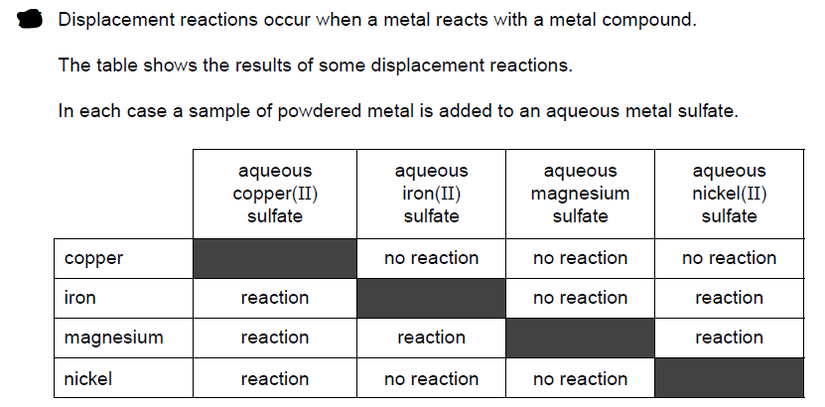

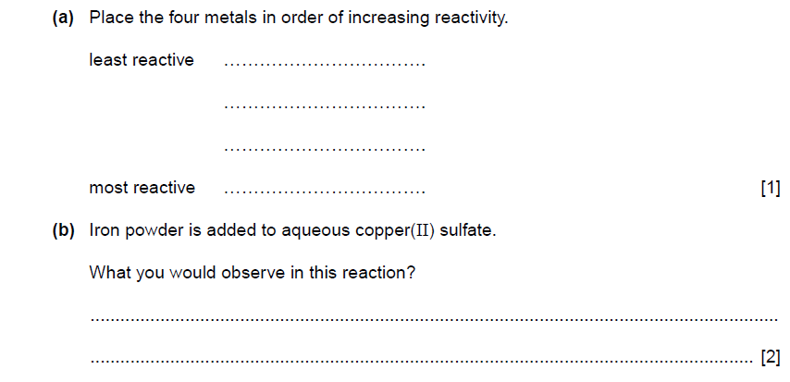

ZZZZ

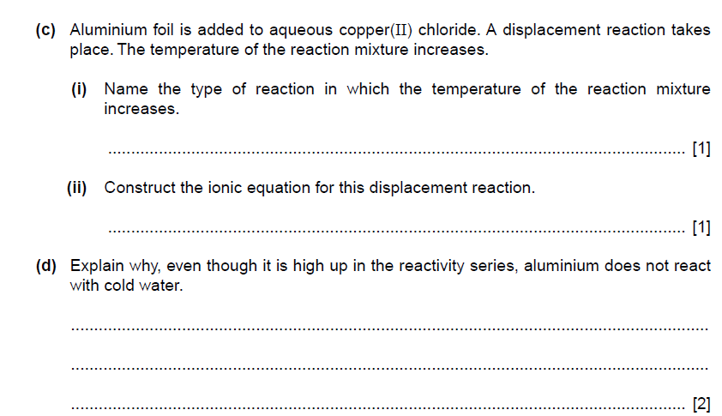

**[TOTAL MARKS 7]**

**Q.NO #2)**

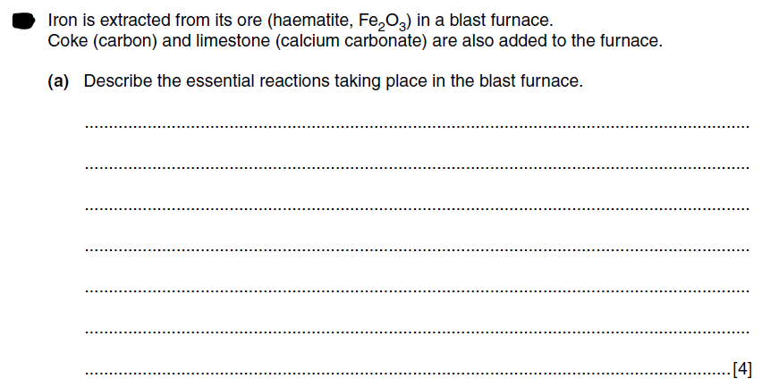

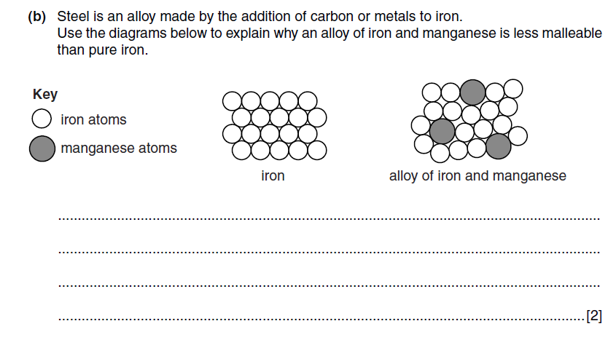

**[TOTAL MARKS 6]**

**Q.NO #3 THIS QUESTION FROM ATP**

The mineral alstonite contains two different cations but only one anion.

The table shows the tests a student does on a sample of alstonite.

Complete the table. Any gases formed should be named.

|  |  |  |
| --- | --- | --- |
| test | observations | Conclusions |
| **(a)** To a portion of alstonite  in a boiling tube, add  dilute hydrochloric acid  until all the solid has  dissolved.  Use the resulting  solution in tests **(b)**, **(c)**  and **(d)**. | The solid dissolves.  Effervescence is observed  and the gas formed turns  limewater milky |  |
| **(b)** To a portion of the  solution from **(a)** in a  test-tube, add dilute sulfuric acid. |  | Alstonite contains Ba+2 ions |

|  |  |  |
| --- | --- | --- |
| **(c)** To a portion of the  solution from **(a)** in a  test-tube, add aqueous  sodium hydroxide until  in excess. |  | Alstonite contain+2 Ca ion |
| **(d)** To a portion of the  solution from **(a)** in a  test-tube, add aqueous ammonia. |  | Alstonite contain Ca+2 ion |

**[Total marks 7]**

**Q.No #4 THIS QUESTION FROM ATP**

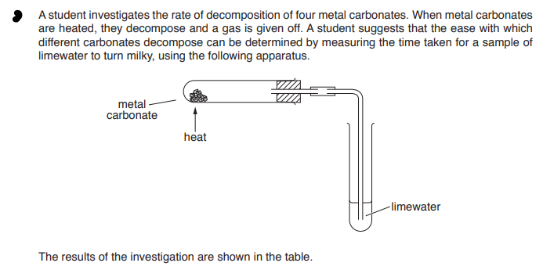

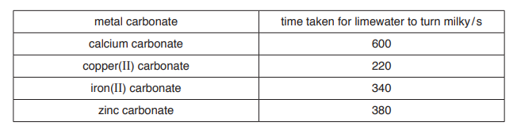

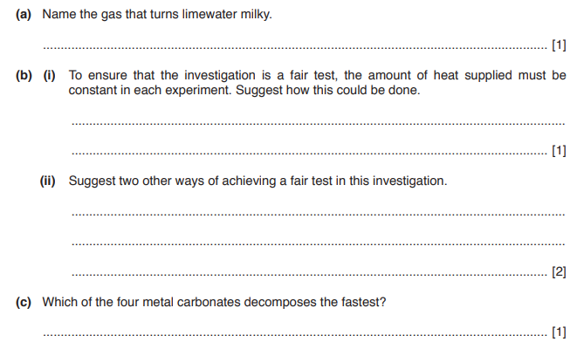

**[total 5 marks]**