The City School
North Nazimabad Boys Campus
Second Monthly Test Session 2019 – 20
Class - 9
Time: 35 Minutes Chemistry Marks 25
Name: ___________________ Sec: ______ Date: ______________
Q.1. Choose the best answers: [5]
- An element X forms a positive ion with the electronic structure 2, 8.8.
- Which of the following contains the same number of electrons as an atom of neon?
- Cl⁻ B. Li⁺ C. C O⁻² D. Na
- The letters X, Y and Z represent different atoms.
atoms | Proton number | Nucleon number
X | 19 | 40
Y | 19 | 39
Z | 20 | 40
- What can be deduced from the proton numbers and nucleon numbers of X, Y and Z?
- X and Y are the same element.
- X and Z are the same element.
- X has more protons than Y.
- Z has more neutrons than Y

- An atom, X, contains 16 protons. Which statement about X is correct?
- It cannot form an ion.
- It contains 6 electrons in the outer shell.
- It contains 6 neutrons.
- It has relative atomic mass of 16.
Q2. Some atoms denoted by the letter A to E, have proton numbers which are
A = 3, B = 10, C = 9, D = 17, E = 11. [3]
- Which of these have complete outermost shell?
…………………………………………………………………………………………………………..
- Which of these are in Group I of Periodic table?
………………………………………………………………………………………………………………………
- Which of these have 7 electrons in there outermost shell?
………………………………………………………………………………………………………………………
Q.3. Give scientific reasons: [4]
- Mg ion is smaller than Mg atom.
…………………………………………………………………………………………………………………………………………………………………………………………………………………………………………………………………………

- Non metals make Anion
…………………………………………………………………………………………………………………………………………………………………………………………………………………………………………………………………………
Q.4. (a) Define the term isotopes. [2]
………………………………………………………………………………………………………………………………………………………………………………………………………………………………………………………………………………………………
(b) Draw atomic structures of isotopes of Hydrogen.

[3]
(c) Radioactive iodine is used to treat some cancerous tumors.
Two radioactive isotopes of Iodine have
- A=125 Z= 53
- A= 131 Z= 53
For each isotope state the type and number of subatomic particles present.
………………………………………………………………………………………………………………………………………………………………………………………………………………………………………………………………………………………………………………………………………………………………………………………………………………………………………………………….…… [2]
(d) Describe the applications of Radioisotopes.
………………………………………………………………………………………………………………………………………………………………………………………………………………………………………………………………………………………………………………………………………………………………………………………………………………………………………… [3]
Q.5. The diagram shows the atomic structure of an atom of element X
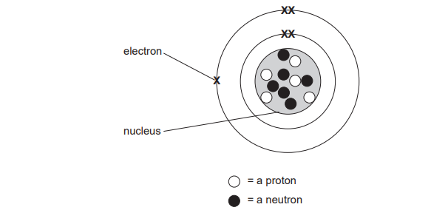
- Complete the given table:
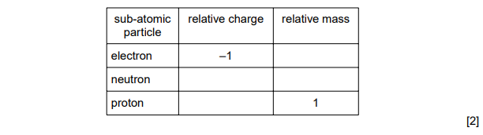
- How many electrons can be occupied by first shell?

………………………………………………………………………………………………………………….…..……. [1]
Look at given atomic structures
Which electron arrangement corresponds to the first element on period 2 of the Periodic Table?

