The City School
North Nazimabad Boys Campus
Second Monthly Test Session 2019 – 20
Class - 9
Time: 35 Minutes Computer Science Marks 30
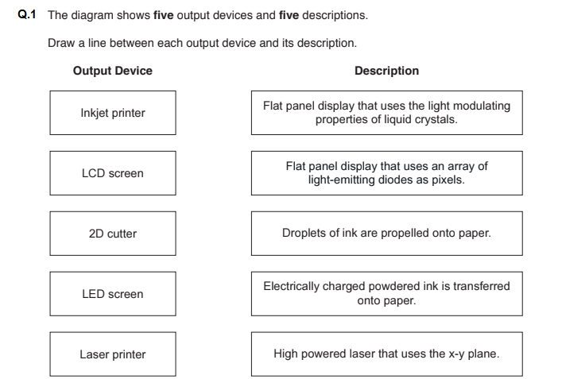
Name: ___________________ Sec: ______ Date: ______________

[5]

Q.2 MP3 file compression reduces the size of a music file by 90%. [2]

a) A music track is 75MB in size. Calculate the file size after compression.
________________________________________________________________________________________________________________________________________________________________________________________________________________________________________________________________________________________________________________________________________

b) How many MP3 files of the size calculated above could be stored on a 900 MB CD?
__________________________________________________________________________________________________________________________________________________________________________________________________________________________________________________________________________________________________________________________________________________________________________________________________________________________

