The City School

**North Nazimabad Boys Campus**

**Second Monthly Test Session 2019 – 20**

**Class - 10**

**Time: 35 Minutes Economics Marks 30**

**Name: ___________________ Sec: ______ Date: ______________**

**(1)** What might a trade union usually be expected to do for its members?

**A.** arrange childcare facilities for members’ children

**B.** ensure adequate promotion prospects exist

**C.** negotiate better working conditions

**D.** provide medical insurance

**(2)** The table shows how three people spend their income.

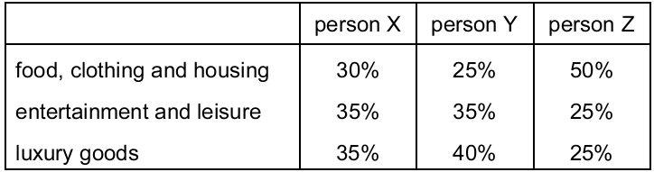

For these three people, what is the most likely order of income, from highest income to lowest income?

**A.** X →Y →Z

**B.** Y →X →Z

**C.** Y →Z →X

**D.** Z →X →Y

**(3)** A trade union agrees on a ‘closed shop’ policy with employers in an industry.

How does this operate?

**A.** All workers will be members of the trade union.

**B.** Employment will be open only to skilled workers.

**C.** The employers cannot make workers redundant.

**D.** Workers cannot move between employers.

**(4)** A government introduces a law to reduce the restrictive practices of trade unions.

What would be the most likely purpose of this law?

**A.** to change from a mixed to a planned economy

**B.** to ensure a fairer distribution of earnings

**C.** to increase competition in labour markets

**D.** to reduce government expenditure on job training

**(5)** The table shows a country’s trade union membership in millions between 2008 and

2011.

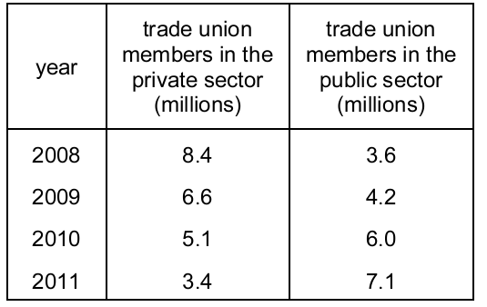

What can be concluded about the country’s trade union membership in the period 2008 to 2011?

**A.** Trade unions had least members in 2010.

**B.** Trade unions had most members in 2011.

**C.** Trade union membership fell between 2008 and 2009.

**D.** Trade union membership rose between 2009 and 2011.

**(6)** A bus driver works longer hours if the wage rate increases. As his earnings increase there

reaches a point when he prefers more leisure to work.

Which supply curve, S, represents this situation?

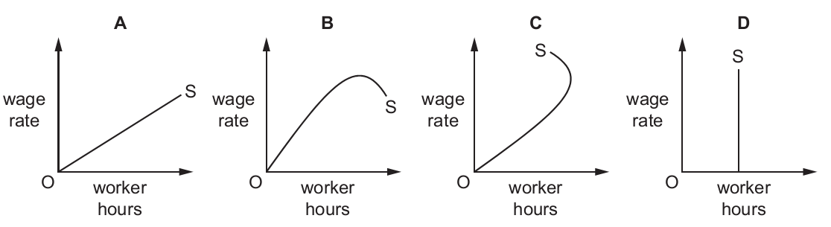

**(7)** A trade union and employers agree a minimum wage (W1) which is above the market

equilibrium wage (W) for that industry.

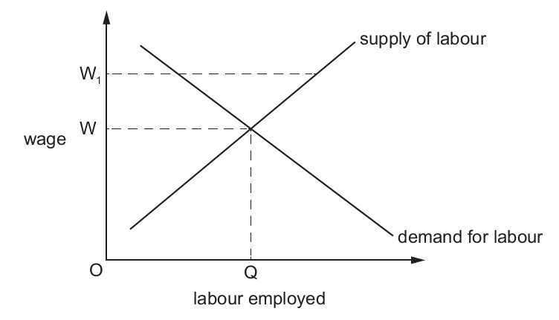

What is the effect of paying the minimum wage (W1)?

**A.** demand for workers will exceed the supply

**B.** fewer workers will be employed

**C.** some workers will continue to be paid at wage W

**D.** workers will be less willing to work for the minimum wage

**(8)** A national trade union wishes to increase the wages of its members without reducing the

numbers employed.

Which factor would help the union to do this?

**A.** The demand for the industry’s product is high.

**B.** The industry consists of a small number of well-organised employers.

**C.** The union workers have low-level skills.

**D.** The workers’ wages are the largest cost of the industry.

**(9)** The wage rate of a worker is reduced.

Which combination of characteristics of the job is most likely to cause the worker to stay in the job?

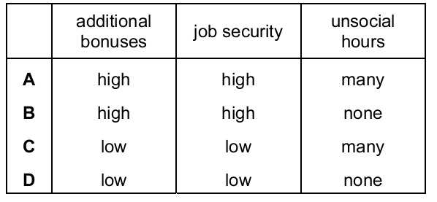

**(10)** Car assembly workers usually earn more income than agricultural workers.

What might explain this?

**A.** Car assembly has safer working conditions.

**B.** Car assembly involves more regular hours.

**C.** Car assembly is usually in smaller firms.

**D.** Car assembly produces a higher-value product.

**(11)** A group of workers in a firm joins a trade union.

What would the union be expected to do?

**A.** arrange for labour-saving technology to be introduced

**B.** discuss safety issues in the workplace with the employer

**C.** ensure job security by promoting the firm’s products through advertising

**D.** negotiate new contracts with major buyers of the firm’s products

**(12)** In which occupations do wages tend to be lowest?

**A.** in those where the work is dangerous

**B.** in those where there is an excess supply of labour

**C.** in those where workers are paid on a monthly basis

**D.** in those where workers need long training

(13) The construction industry in Dubai relies on many migrant workers from India.

Which combination of changes in the economies of Dubai and India would be most

likely to increase the wages of construction workers in Dubai?

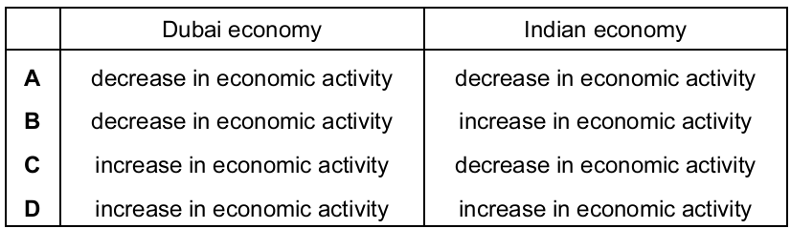

**(14)** What may cause an individual to save a higher proportion of their income?

**A.** a belief that the price of goods will rise in the future

**B.** a fall in the rate of interest paid by the country’s banks

**C.** a fear that income will fall in the future

**D.** a rise in the individual’s wish to enjoy higher consumption immediately

**(15)** Why are unskilled workers paid less than skilled workers?

**A.** There is a higher demand for unskilled labour than skilled labour.

**B.** There is a larger supply of unskilled labour than skilled labour.

**C.** Unskilled labour belong to trade unions.

**D.** Unskilled labour is more productive than skilled labour.

**(16)** A trade union is negotiating a wage rise for its members.

What will increase the chance of the wage rise being granted?

**A.** The company’s product has many substitutes.

**B.** The economy is entering a period of recession.

**C.** The government has made strike action illegal.

**D.** Wages are a small part of the company’s costs.

**(17)** In a particular industry, male workers on average are paid more than female workers.

What might explain this?

**A.** Female workers are less likely to take time off work.

**B.** Female workers are more likely to be in trade unions.

**C.** Male workers have higher qualifications.

**D.** Male workers live nearer to their place of work.

**(18)** What is most likely to cause a person to save a larger proportion of their weekly income

rather than spend a larger proportion of their weekly income?

**A.** a decrease in the tax on goods and services

**B.** a decrease in weekly income

**C.** an increase in interest rates

**D.** an increase in the range of products available

**(19)** Which of the following is most likely to limit wage increases in an industry?

**A.** an increased demand for the industry’s product

**B.** a rise in the industry’s profits

**C.** a rise in wages for workers in similar jobs

**D.** the replacement of workers with robots

**(20)** What is a function of a trade union?

**A.** to negotiate workers’ contracts

**B.** to promote workers to more responsible jobs

**C.** to recruit workers for the firm

**D.** to supervise the workers in the firm

**(21)** What will be likely to increase the wages of airline pilots?

**A.** Incomes increase in the world’s major economies.

**B.** Terrorist attacks decrease tourist travel.

**C.** The cost of aviation fuel rises.

**D.** The world economy goes into recession.

**(22)** What is **most** likely to help a trade union’s claim for wage increases in an industry?

**A.** a decrease in the price of a close substitute for the product

**B.** a decrease in the qualifications needed for the job

**C.** an increase in the number of workers

**D.** an increase in the profits of the industry

**(23)** The table shows some information for a computer engineer in 2015.

Income tax is fixed at 20%. The engineer saved 10% of the disposable income.

How much was saved?

**A** $3200 **B** $4000 **C** $4400 **D** $5500

**(24)** What is likely to lead to an increase in the wages of university lecturers?

**A.** an increase in the fringe benefits provided to university lecturers

**B.** an increase in the tuition fees paid by university students

**C.** government policies reducing the length of the training for university lecturers

**D.** increased demand from students to study at university

**(25)** When is a trade union likely to have more power to increase its members’ wages?

**A.** when imports are increasing

**B.** when labour supply is increasing

**C.** when output is increasing

**D.** when unemployment is increasing

**(26)** The table shows the percentage (%) of income saved by different age groups.

What can be concluded from the table?

**A.** Over the age range shown total savings equalled total dissavings.

**B.** The 15–29 age group has the lowest level of income.

**C.** The 50–64 age group saves the highest percentage of its income.

**D.** The 65+ age group has a lower income than the 30–39 age group.

**(27)** The table shows government estimates of the private and external benefits and costs of

building a new dam.



What is the difference between the social benefits and social costs of building the dam?

**A.** $25 million

**B.** $50 million

**C.** $175 million

**D.** $225 million

**(28)** What is likely to happen when the rate of interest increases?

**A.** consumer spending increases

**B.** firms buy fewer machines

**C.** people hold more cash

**D.** savers earn lower rewards

**(29)** In which type of work are employees most likely to earn their highest income at a

relatively young age?

**A.** manual building work

**B.** professional legal work

**C.** skilled craft work

**D.** university teaching work

**(30)** What is most likely to be used to support a claim for wage increases in an industry?

**A.** a decrease in the industry’s sales

**B.** a decrease in the need for specialist training

**C.** an increase in cheap imports of a rival product

**D.** an increase in wages in a similar industry