The City School
North Nazimabad Boys Campus
Second Monthly Test Session 2019 – 20
Class - 11
Time: 35 Minutes English Language Marks 20
Name: ___________________ Sec: ______ Date: ______________
Reading for Meaning
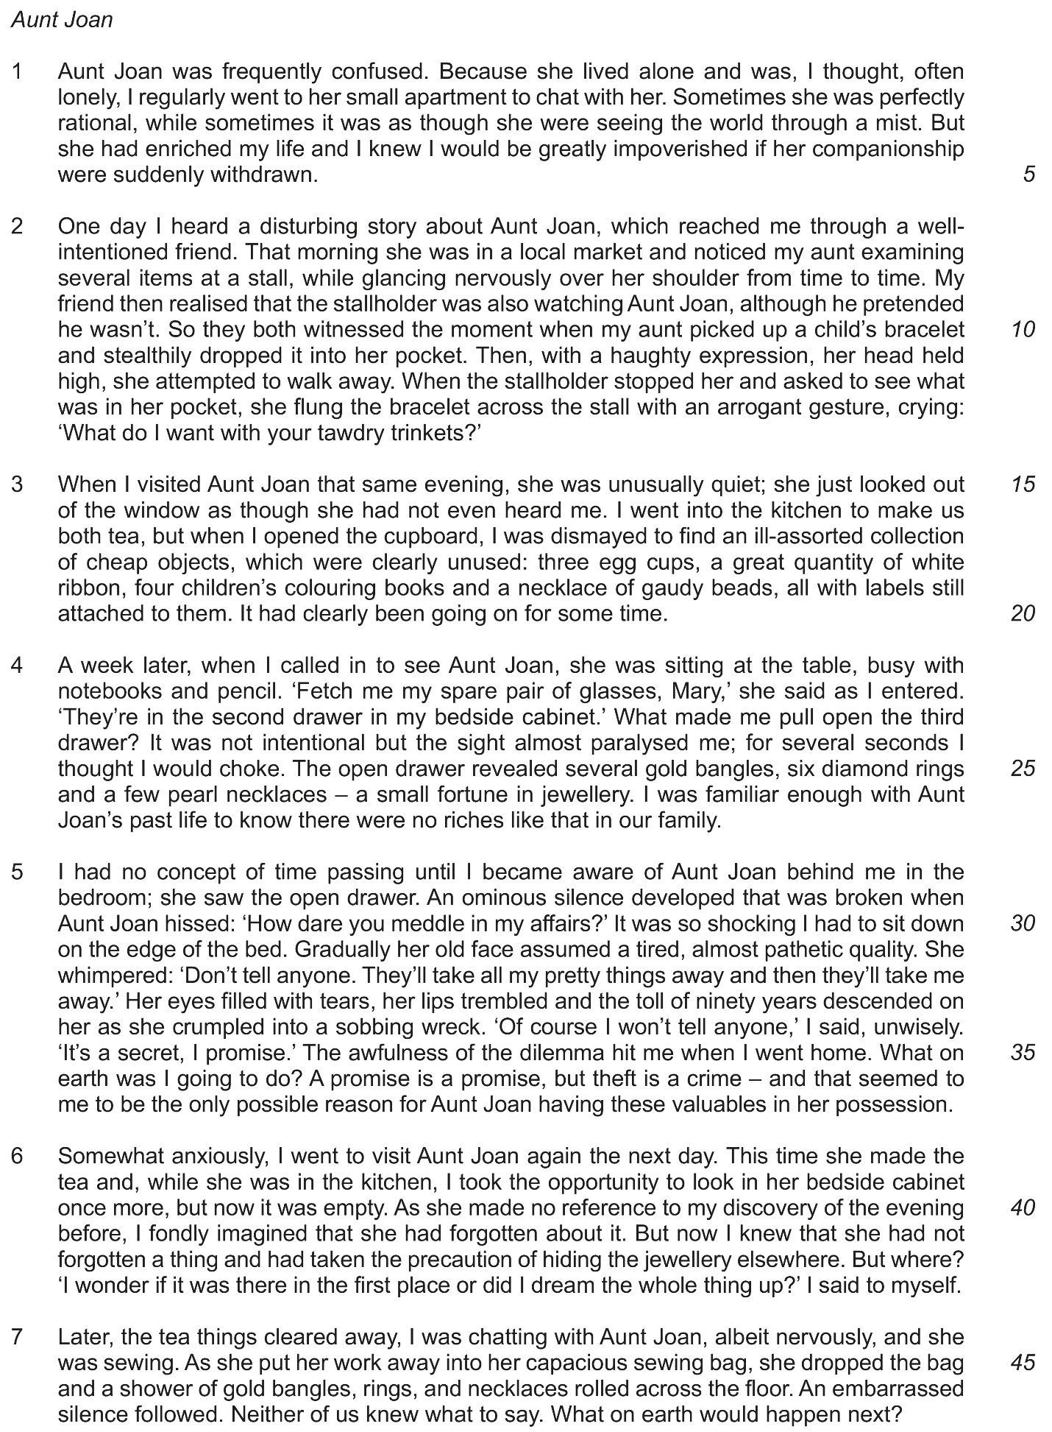

Read Passage, Aunt Joan, in the Insert and answer all the questions below.

From paragraph 1
3 (a) Why did the writer regularly visit Aunt Joan?

............................................................................................................................................. [1]

(b) In what way does the writer indicate that Aunt Joan was ‘frequently confused’ (line 1)?

............................................................................................................................................. [1]
From paragraph 2
4 (a) What two things did Aunt Joan do which showed that she knew she was doing something
wrong?
(i) ...........................................................................................................................................

...........................................................................................................................................

(ii) ...........................................................................................................................................

..................................................................................................................................... [2]
(b) Aunt Joan attempted to walk away ‘with a haughty expression, her head held high’ (lines 11–12).

Give one word used later in the paragraph which continues this idea.

............................................................................................................................................. [1]
From paragraph 3
5 (a) Why does the writer think that the objects in the cupboard ‘were clearly unused’ (line 18)?

............................................................................................................................................. [1]
(b) ‘It had clearly been going on for some time.’ (line 20) What does ‘it’ refer to?

............................................................................................................................................. [1]
From paragraph 4
6 (a) What mistake did the writer make when Aunt Joan asked her to fetch her spare pair of
glasses?
............................................................................................................................................. [1]
(b) ‘It was not intentional but the sight almost paralysed me; for several seconds I thought I would choke.’ (lines 24–25)
Describe in your own words the writer’s reaction to what she saw in the drawer.

...................................................................................................................................................

...................................................................................................................................................

............................................................................................................................................. [2]
From paragraph 5
7 (a) Why did Aunt Joan go into the bedroom?

............................................................................................................................................. [1]
(b) ‘Aunt Joan hissed’ (line 30). What emotion do you think she was feeling?

............................................................................................................................................. [1]
(c) ‘A promise is a promise, but theft is a crime’ (line 36). Explain in your own words why the
writer thought she had a ‘dilemma’.

...................................................................................................................................................

...................................................................................................................................................

............................................................................................................................................. [2]
From paragraph 6
8 The writer looked in Aunt Joan’s ‘bedside cabinet once more, but now it was empty’ (lines 39–40).
(i) What was she looking for?

...........................................................................................................................................

..................................................................................................................................... [1]
(ii) Why was the drawer empty?

...........................................................................................................................................

..................................................................................................................................... [1]

9 From paragraphs 1–7
For each of the words below, circle the letter (A, B, C or D) which has the same meaning that the word has in the passage.

(a) enriched (line 4)
A helped B financed C improved D developed [1]
(b) fortune (line 26)
A luxury B wealth C value D luck [1]
(c) ominous (line 29)
A strange B threatening C serious D deep [1]
(d) fondly (line 41)
A kindly B affectionately C proudly D foolishly [1]
(e) capacious (line 45)
A large B extended C wide D comfortable [1]

10 Re-read paragraphs 5 and 6, which contain sentences telling us (a) what Joan said and (b) what the writer said.
Give:
- the meaning of each sentence as it is used in the passage
- the effect of each sentence as it is used in the passage.

(a) ‘“They’ll take all my pretty things away and then they’ll take me away.”’ (lines 32–33)

Meaning ....................................................................................................................................

...................................................................................................................................................

Effect .........................................................................................................................................

............................................................................................................................................. [2]
(b) ‘“I wonder if it was there in the first place or did I dream the whole thing up?” I said to myself.’ (line 43)

Meaning .....................................................................................................................................

...................................................................................................................................................

Effect ..........................................................................................................................................

............................................................................................................................................. [2]

