The City School
North Nazimabad Boys Campus
Second Monthly Test Session 2019 – 20
Class - 10
Time: 35 Minutes Islamiyat Marks 20
Name: ___________________ Sec: ______ Date: ______________
Q1:
(a) briefly describe the main theme of the passage. [2]
(b) briefly explain the importance of the theme in a Muslim’s life today. [2]
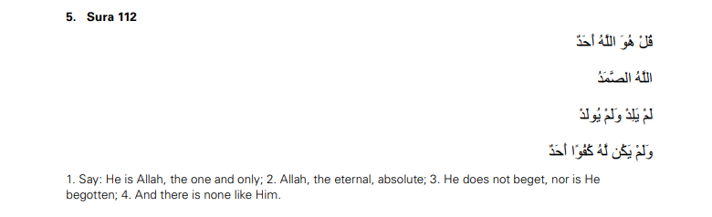Q2:
(a) describe their teachings about what Muslims believe. [2]
(b) explain how Muslims can put these teachings into action. [2]
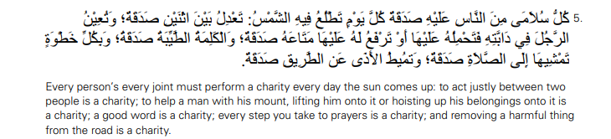Q3:
(a) The Angel Jibril brought the revelation of the Qur’an to the Prophet Muhammad at different
times and places. Give examples to show how this took place. [10]
(b) What was the significance of the Prophet being given the revelation by word rather than in
writing? [2]

