The City School
North Nazimabad Boys Campus
Second Monthly Test Session 2019 – 20
Class - 11
Time: 35 Minutes Physics Marks 20
Name: ___________________ Sec: ______ Date: ______________
Q1. A fuse is one form of protection in an electrical circuit.

  - State two other forms of protection that are included in household electrical circuits. These may protect the consumer, the circuit or an electrical appliance.
- ....................................................................................................................................
- .................................................................................................................................... [2]

- Fig. 1 shows a fusebox connected to part of a lighting circuit in a house. fusebox
fuse

wire W

Fig 1
- State how Fig. .1 shows that wire W is the live wire.

...........................................................................................................................................
.......................................................................................................................................[1]

- On Fig. .1, mark with a letter s, the correct position for a switch that controls both lamps. [1]

- The rating of the fuse in the lighting circuit is 5 A. Explain what this means.
...........................................................................................................................................
...........................................................................................................................................
.......................................................................................................................................... [2]

Q2.A student connects a battery to two resistors. The circuit diagram is shown in Fig. 2

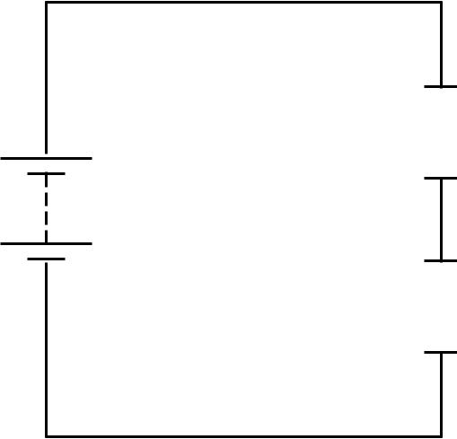

10 Ω

40Ω

Fig 2

The potential difference (p.d.) across the 40 Ω resistor is 9.6 V.
- State what is meant by the potential difference across a resistor.

...................................................................................................................................................
...............................................................................................................................................[2]
- (i) Calculate the current in the 40Ωresistor.

current = ........................................................... | [3]
- Calculate the electromotive force (e.m.f.) of the battery.

e.m.f. = ........................................................... | [2]

- The student has three different voltmeters to measure the p.d. across the 40 Ω resistor. These are labelled 0–2 V, 0–20 V and 0–200 V. Each has a pointer that shows the p.d. on a scale. State and explain which of the three voltmeters is best to measure this p.d.
...................................................................................................................................................
...................................................................................................................................................
...................................................................................................................................................
...............................................................................................................................................[2]

- (i) Calculate the powerP produced in the 10Ωresistor.

P = ........................................................... | [3]

- The student has available two 10 Ω resistors, with power ratings of 1/2P and 2P.

Suggest why a resistor with a power rating of 1/2 P is not suitable for the circuit in Fig. 2.

....................................................................................................................................................
................................................................................................................................................. [2]
Q3.Fig. shows a circuit diagram containing a 2000 Ω resistor of constant resistance and a thermistor.
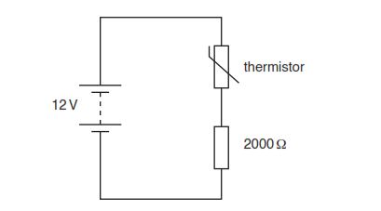

(a) (i) At one temperature, the resistance of the thermistor is 1200 Ω.

Calculate the potential difference (p.d.) across the 2000 Ω resistor at this temperature.

p.d. = ......................................................... [2]
(ii) Explain why the p.d. across the 2000 Ω resistor increases when the temperature increases.
................................................................................................................................................................................
................................................................................................................................................................................
................................................................................................................................................................................
............................................................................................................................................................................. [3]

