The City School
Class 10T
(Principles Of Accounting)
Date: 18-06-2016
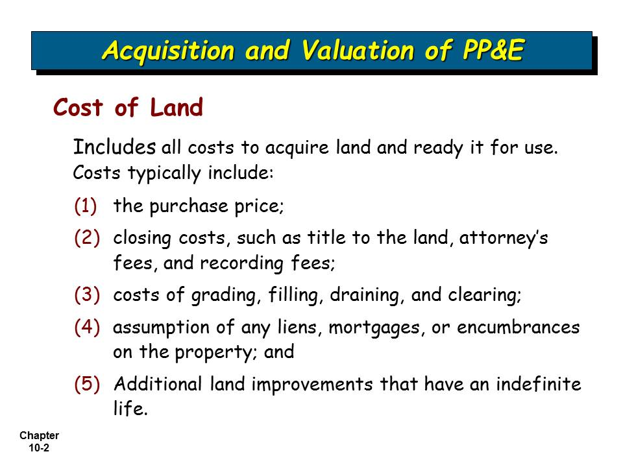
Teacher: Zafar Iqbal

