**The City School**

North Nazimabad Boys Campus

Subject: Mathematics

Class 9th

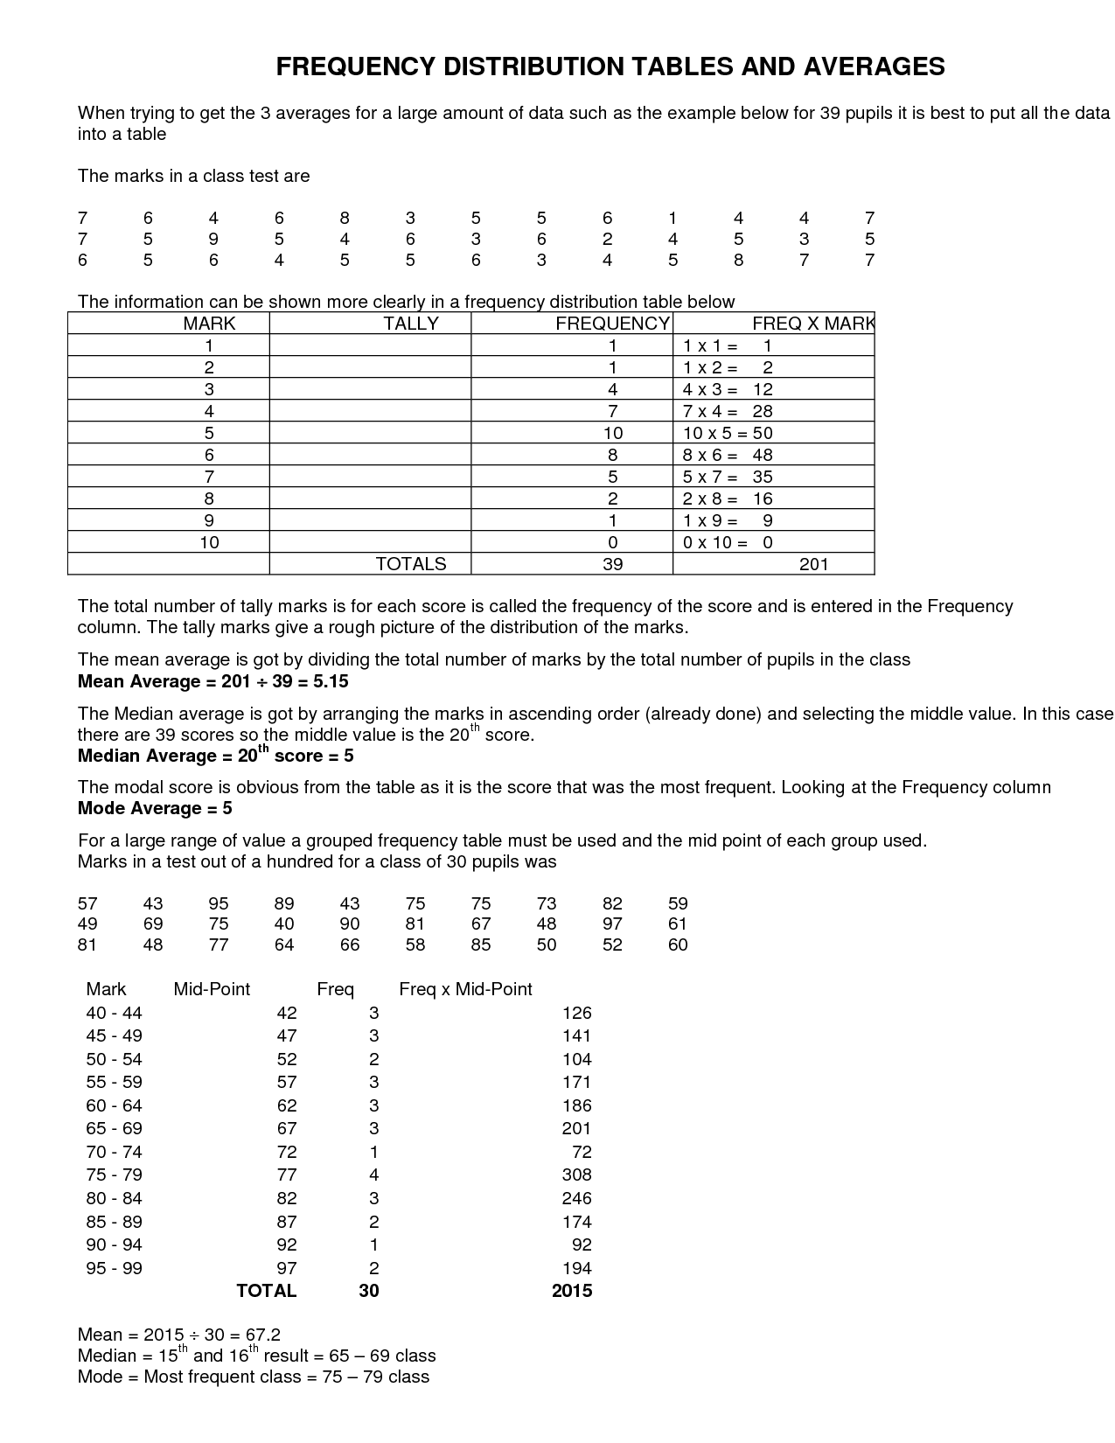

Draw the table for the cumulative graph given below and

1. What is the cumulative frequency at 71 inches?
2. If the boy height showing cumulative frequency 121 then what will be the height of the boy actually.

