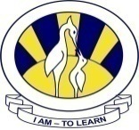
The City School
North Nazimabad Boys Campus
3rd Monthly test syllabus

Date: 11-11-2015
Subject: Math
Class: 11TH
Teacher: Mahrukh

- Trigonometry
- Geometrical properties of circle
- Isometric transformation

