The City School
North Nazimabad Boys Campus
Topic: Mixed Concept (Paper II)
Mr. MohsinZaki
Subject: Mathematics
Grade: 09
Q1: Solve the following equations, where possible giving your answers correct to 2 decimal places where necessary.
- $\frac{5}{x+1}+ \frac{8}{x+3}=5$ b. (3x-1)(2x+5) = (4 - x²)
- $\frac{8}{x-1}+ \frac{3}{x-2}=3$ d. 5x²+4x+5 = 3(1-3x)
Q2: A man transferred US $ 50,000 to a United State Bank when US$ 1 = Singapore $1.84. How much amount he deposited.
Q3: Two vertical posts are 14m apart. One is 3m high and the other is 1.6m high. Find
- the distance between the top of two posts
- the angle made by the line joining the tops of the two posts with the horizontal.
Q4: The width of a rectangle is (x + 2)cm. The perimeter of the rectangle is 6(x+1)cm. The area of the rectangle is 18cm²
Show that 2x² + 5x -16 = 0
Q5: The table shows the marks obtained in tests of English and Mathematics by 140 students.
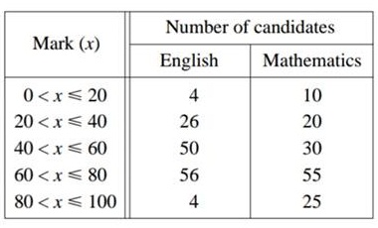
- Copy and complete the cumulative frequency table below
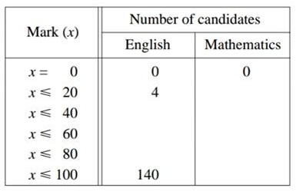
- Using a scale of 2 cm to represent 20 marks, draw a horizontal x-axis for 0 ≤ x ≤ 100.
Using a scale of 2 cm to represent 20 pupils, draw a vertical axis for values from 0 to 140.
On your axes, draw a label both smooth cumulative frequency curve to illustrate this information.
- Use your curves to find
- the upper and lower quartile mark for English and Mathematics.
- the inter quartile range for English and Mathematics.
- State, with a reason, which you think is the easier test.
Q6: A solid metal ball of radius 3cm is melted and the metal obtained is recast to form a solid circular cone of radius 4cm. Find the height of the cone.
Q7: If a is inversely proportional to the cube of b and that a = 5 when b = 6, find
- The equation connecting a and b
- The value of a when b=3
- b when a =135
Q8: Ali walked a distance of 25km from A to B, at an average speed of x km/hr. Write down an expression for the time in hours, he took for the journey from A to B.
He returned by the same route but his average speed was 2km/hr less. Write down an expression for the time, in hours, he took the journey from A to B.
Given that the difference between the two times was 35minutes, form an equation in v and show that it reduced to 7x²-14x-600=0
Solve the above equation correct to 2 decimal places. Hence find the total time taken for the men to walk , giving your answer correct to the nearest minute

