The City School
North Nazimabad Boys Branch
Grade: 9
Subject : Physics
Topic: Work Energy and Power
Teacher: Faisal Sarfaraz

Q1 (a) Define force and its SI Unit.

(b) Two forces acting at a point which have a magnitude of 3N and 4N. By means of lines show the line of action of forces when their resultant is (i) 7N (ii) less than 7N but more than 1N (iii) 1N

(c) Two forces of 50N and &70N acting on a point so that the angle between their line of action is 40⁰. By means of a scale diagram, determine the magnitude and direction of resultant force acting at the point.
(d) In a study on impact, a bullet of mass 50g penetrates a target and is brought to rest from an initial speed of 500m/s in 0.2 sec.
Calculate the average deceleration of the bullet of 0.2 sec
Find the retarding force against on the bullet during its impact with the target

Q2: A student Ben, starting at point P, walks due North for 1hr at a constant speed of 4.0km/h and then, at the same constant speed, walks 4.0km due East, finishing at a point Q. In the same total time but at a different constant speed, a second student Tom walks directly from P to Q. Determine

- The total distance walked by the student Ben
- The distance walked by student Tom
- The velocity of student Tom

Q3: A motor boat travels due north at a steady speed of 3.0m/s through calm water in which there is no current. The boat then enters an area of water in which a steady current flows at 2.0m/s in a south-west direction as shown. Both the engine power and the course setting remain unchanged.

(a) In the space below, draw a vector diagram showing the velocity of the boat and the velocity of the current. Use the diagram to find
i. the magnitude of the resultant velocity of the boat
ii. the angle between the due North and the direction of travel of boat. (b)Calculate the distance the boat now travels in 5.0 minutes
(c) The mass of the boat is 3.0 x 103 kg (3000 kg). Calculate the additional force which needs to be
applied to give the boat an initial acceleration of 2.5 x 10-2 m/s2 (0.025 m/s2)

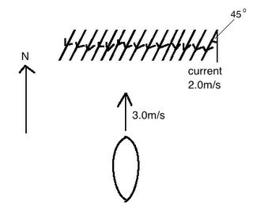
Q4: In a laboratory experiment, a small trolley was accelerated from rest by applying a small force to it. The distance travelled by the trolley was measured as 1.1 m in a time of 0.55 s. Calculate its average speed.
During this movement, the trolley was uniformly accelerating from rest. Calculate its speed after
0.55 s and its acceleration during this speed.
The mass of the trolley is 1.2 kg. What is the force producing this acceleration?

