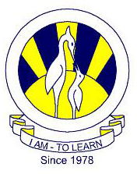
The City School
North Nazimabad Boys Campus
Worksheet#2
Chemistry class 9

Q.1. choose the best answers:
- Brass is an example of
- An alloy
- a compound
- a mixture
- an elementAnswer A
- A particle may be
- an atom
- a molecule
- an isotope
- all of theseAnswer D
III. Other than O and C, main elements of a brick wall includes
- Silicon (Si)
- Calcium (Ca)
- Aluminum (Al)
- Both A and BAnswer D
IV. Symbol of Magnesium is
- Mg
- Mn
- Hg
- M
Answer A
V.. Naturally occurring elements are
- 82
- 92
- 99
- above 100 by nowAnswer B
VI. Electronic thermometers
- are mercury in glass thermometer
- alcohol in glass thermometer
- are used to reduce risk of mercury poisoning if broken
- are greatly replaced by alcohol in glass thermometerAnswer C
VII. Unit for volumes does not include
- ccm
- cdm
- liters
- tonesAnswer D
VIII. 100 cm³, 250 cm³ and 1 dm³ can be measured using
- measuring cylinder
- beaker
- volumetric flask
- burette
Q.2. Cite four differences between compounds and mixtures:

