The City School
North Nazimabad Boys Campus
Topic: Mixed Concept (Paper II)
Mr. MohsinZaki
Subject: Mathematics
Grade: 09
Q1: y = p² +6p
- Find the value of p when y = 3
Give your answer correct to two decimal places
Q2: A ladder 5.8 m long stands on level ground and its top just reaches the top of a wall 4.1 m high. How far is the foot of the ladder from the wall?
Q3: The length of the diagonal of a rectangular board is 61 m and the length of one side is 60 m. Find:
a. the width of the board
b. area of the board
Q4: 200 students took a test. The cumulative frequency graph information about their marks is shown below:

Use your graph to estimate
- Median, Lower Quartile, Upper Quartile
- Inter Quartile Range
20th and 80th Percentile
Q5: A square has side length (x+2)cm. A right – angled isosceles triangle has its two equal sides of length (2x + 1)cm. The area of the square is equal to the area of triangle.
- Write down an equation in x
- Show that your equation simplifies to 2x² – 4x -7
- By solving the equation find the perimeter of a square.
Q6: Find the unknown values in the given figure. Give your answer correct to two significant figures or nearest degree
- 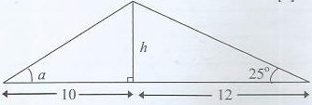
Q7: Given circle has a radius of 11cm. Take π=3.142 to calculate
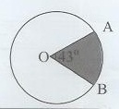
i) the length of the minor arc AB
ii) the area of the minor sector AOB
Q8: A straight line px = 5y + 4 has the same gradient as the line 7x + 6y + 5 =0. Find the value of m.
Q9: A shopkeeper buys paint at $32 per tin. He marks up the price of eah tin of paint such that he can make a profit of 15% in each tin.
- Find the selling price of each tin.
- Calculate the total; amount that customer has to pay for 5tins of paint.

