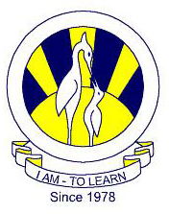
The City School
North Nazimabad Boys Campus
Worksheet#2
Biology class 9

Q.1. (a) Look at the diagram and match the given organs of digestive system:(any five)

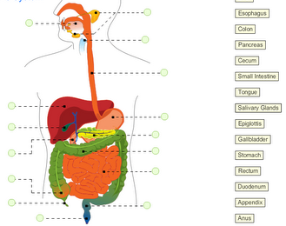
(b) Discuss the function of pancreas and small intestine in the process of digestion.
Q.2. (a) State the names of digestive enzymes.
(b) Complete the given equations of digestion by writing the names of appropriate enzymes.
- Protein →Amino Acid
- Fats →fatty acid+ glycerol
- Carbohydrate →glucose

