The City School
North Nazimabad Boys Campus
Grade 09
Mr Mohsin Zaki

Subject: Mathematics
Date: 23-09-2016
Q1: Find unknown side of the triangle given:
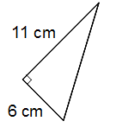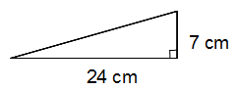

Q2 : A ladder 5.8 m long stands on level ground and its top just reaches the top of a wall 4.1 m high. How far is the foot of the ladder from the wall?
Q3: The length of the diagonal of a rectangular board is 61 m and the length of one side is 60 m. Find:
a. the width of the board
b. area of the board
Q4: Find the total area of A and B:

