The City School
North Nazimabad Boys Branch
Grade 9 Mathematics
Topic: Practical Application of Trigonmetry
Date: 07-10-2016
Mr. MohsinZaki
Q1: From the top of a light house 60 meters high with its base at the sea level, the angle of depression of a boat is 15 degrees. What is the distance of boat from the foot of the light house?
Q2: The angle of elevation of the top of an incomplete vertical pillar at a horizontal distance of 100 mt from its base is 45 degrees. If the angle of elevation of the top of the complete pillar at the same point is to be 60 degrees, then the height of the incomplete pillar is to be increased by how much ?
Q3:A nursery plants a new tree and attaches a guy wire to help support the tree while its roots take hold. An eight foot wire is attached to the tree and to a stake in the ground. From the stake in the ground the angle of elevation of the connection with the tree is 42º. Find to the nearest tenth of a foot, the height of the connection point on the tree.
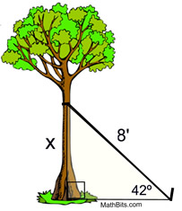
Q4: From the top of a fire tower, a forest ranger sees his partner on the ground at an angle of depression of 40º. If the tower is 45 feet in height, how far is the partner from the base of the tower, to the nearest tenth of a foot?
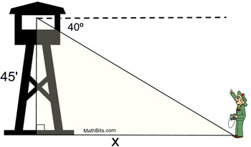
Q5:A radio station tower was built in two sections. From a point 87 feet from the base of the tower, the angle of elevation of the top of the first section is 25º, and the angle of elevation of the top of the second section is 40º. To the nearest foot, what is the height of the top section of the tower?
