The City School
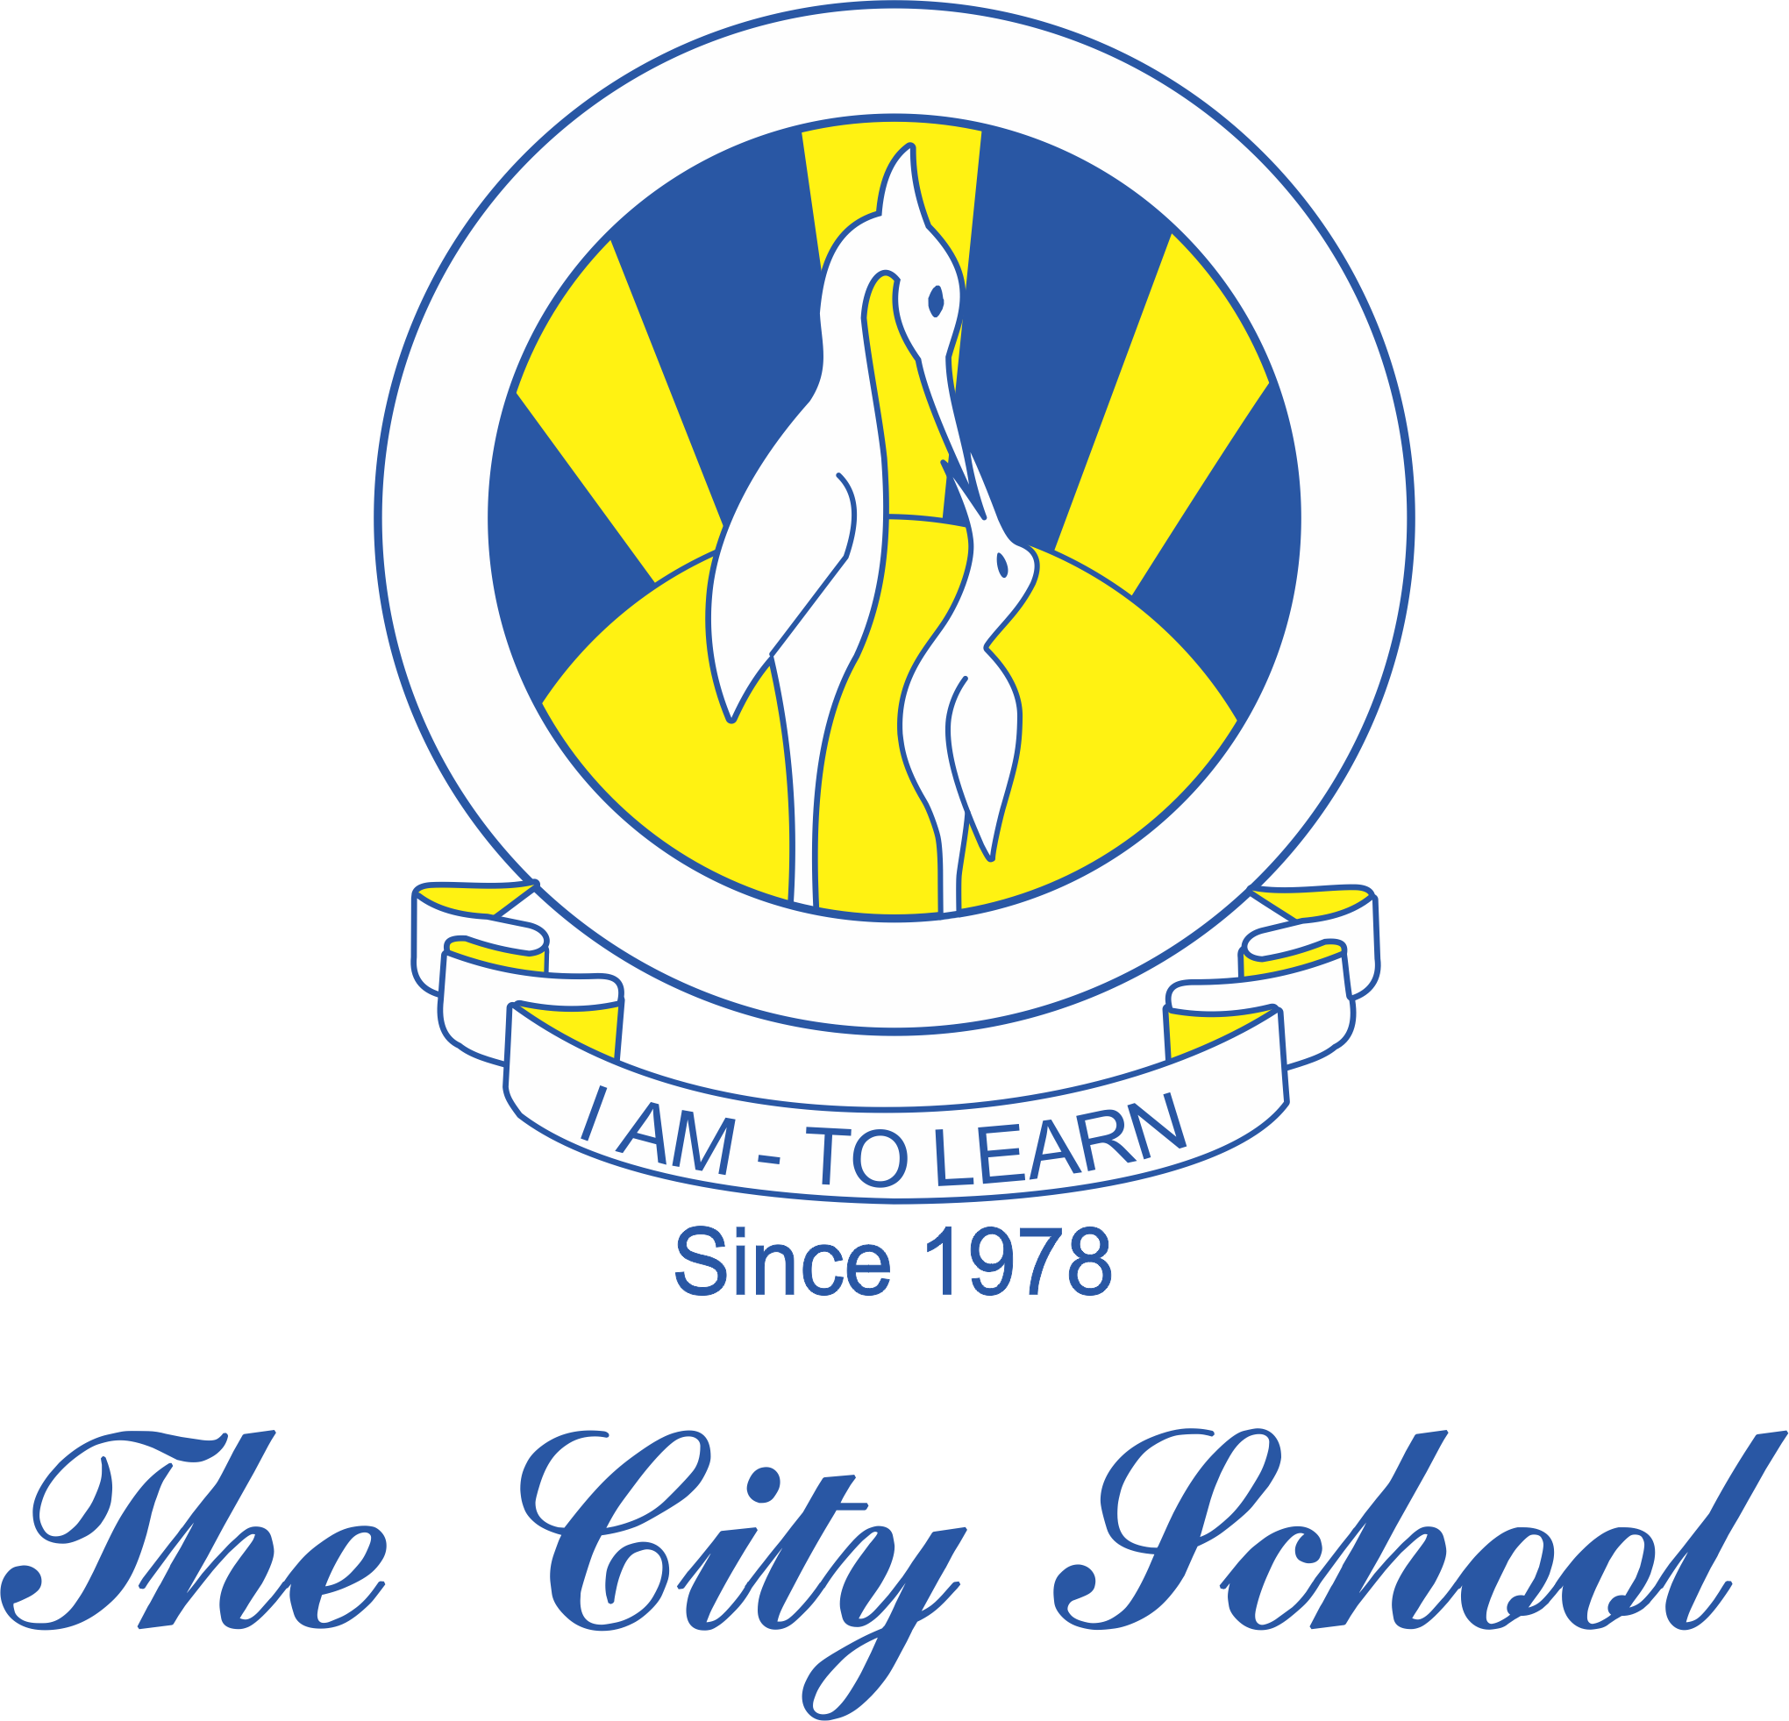
North Nazimabad Boys Campus
Consolidated Syllabus for Grade 9 EOY 2018 - 19
Accounting

- Role of Accounting.
- The Double Entry System of Book Keeping.
- Documentary Records.
- The General Journal.
- The Ledger.
- The Trial Balance.
- Books of Prime Entries.
- Cash Book.
- Bad Debts (Provision for doubtful debts)
- Income Statement & Financial position with adjustment of provision for doubtful debts
- Bank Reconciliation

