The City School
North Nazimabad Boys Campus
Date: 11-03-2017
Subject: Accounts
Class: 9-T
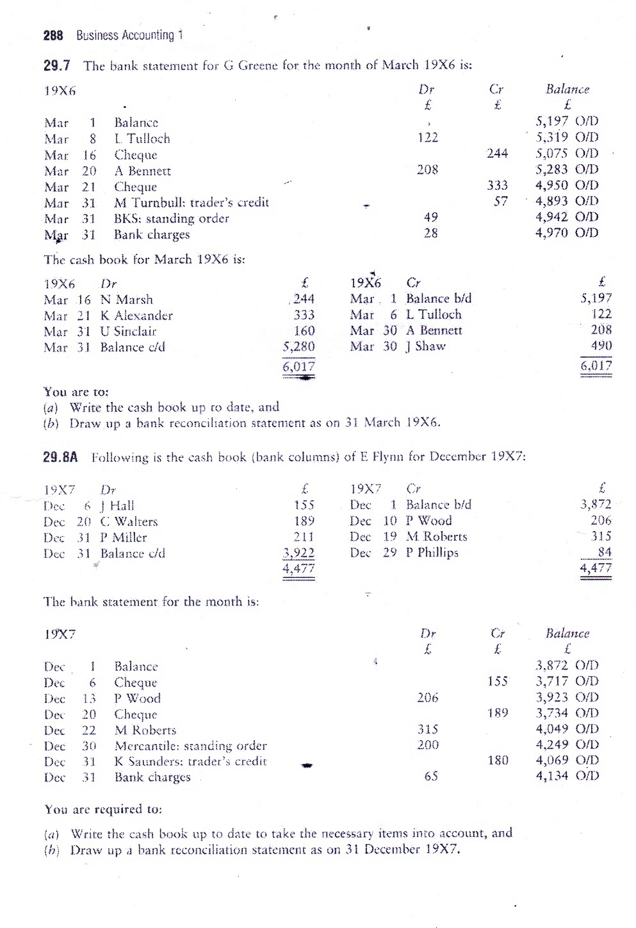
Teacher: Fazal Ur Rahman

