O LEVEL CHEMISTRY 5070 ACIDS, BASES & SALTS

WORKSHEET SHEET 1

A food scientist checked the quality of a bottle of vinegar.
He took 50 cm3 of the vinegar and found out how much sodium hydroxide was needed to neutralise it.

- Explain what is meant by ‘neutralise’

………………………………………………………………………………………………………………………………………………………………………………………………………………
- What apparatus could the scientist have used to measure the amount of sodium hydroxide needed?

..........................................................................................................................................................................................

He also tested some ethanoic acid solution. Ethanoic acid is the acid which is found in vinegar.
His results are shown below.
.
 | vinegar | ethanoic acid
3  volume used/cm | 50 | 10
volume of NaOH needed  3  to neutralise/cm | 30 | 10

The ethanoic acid solution contained 10 g of acid in every 100 cm3 of solution.

- How many grams of ethanoic acid are there in 10 cm3 of solution?

…………………………………………………………………………………………………………………………..

- How many grams of ethanoic acid are there in 10 cm3 of solution?

……………………………………………………………………………………………………………………………………………………………………………………………………………………………………….

- Work out how many grams of ethanoic acid are in 50 cm3 of the vinegar.
……………………………………………………………………………………………………………………………………………………………………………………………………………………………………
- What must you assume is kept constant to allow you to work out the answer to (E) ?

……………………………………………………………………………………………………………………………………………………………………………………………..

WORKSHEET SHEET 2

Small pieces of the metals copper, magnesium, nickel and zinc were placed in test tubes containing small
quantities of hydrochloric acid. The following results were observed.

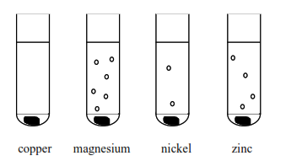

- Use the observations from above to complete the following reactivity series.

MOST REACTIVE

LEAST REACTIVE

- What is the name of the gas produced in the above reactions?

………………………………………………………………………………………………………..

- Describe the test and result you would use to identify this gas.

……………………………………………………………………………………………………………………………………………………………………………………………………………………………………
- The reaction between the metals and the hydrochloric acid also produces a chemical compound
known as a salt.

- What is the name of the salt formed in the reaction between magnesium and hydrochloric acid?

……………………………………………………………………………………………………………………………………………………………………………………………………………………………………
- What type of bonding is present in this salt?

……………………………………………………………………………………………………………………………………………………………………………………………………………………………………

- This salt is a solid at room temperature. Explain why a salt has a high melting and boiling point.
……………………………………………………………………………………………………………………………………………………………………………………………………………………………………

QUESTIONSHEET 3

The following experiment was carried out using concentrated ammonia solution and concentrated hydrochloric acid.

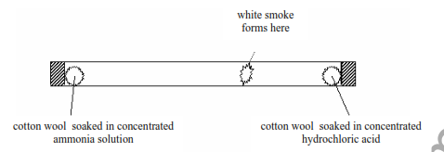

Ammonia contains the elements hydrogen and nitrogen and has the chemical formula NH3.

- Name the type of bonding that exists in ammonia

…………………………………………………………………………………………………….

- Use the Periodic Table to draw a 'dot and cross' diagram to show the bonding in a molecule of
ammonia. You need only show the electrons in the outer energy level.

- Explain why ammonia has a low boiling point.

……………………………………………………………………………………………………………………………………………………………………………………………………………………………………
The ammonia and hydrogen chloride gases meet and react to form the ring of white smoke which is
shown in the diagram.

- Explain, in terms of the particles of the gases, why the gases meet

…………………………………………………………………………………………………………………………………………………………………………………………………………………………………..

- Explain why the ring of white smoke forms nearer to the concentrated hydrochloric acid.

…………………………………………………………………………………………………………………………………………………………………………………………………………………………………………………………………………………………………..

- What is the name of the chemical formed when ammonia and hydrogen chloride react?

…………………………………………………………………………………………………………………………………………………………………………………………………………………………………………………………………………………………………………

WORKSHEET 4

The diagram below shows an experiment to measure the rate of reaction between calcium carbonate and
sulphuric acid.

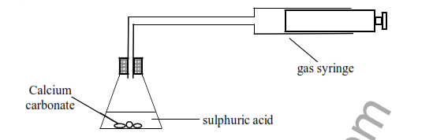

The reaction between calcium carbonate and sulphuric acid produces a chemical compound called a
salt, a gas and water
- The gas produced can be identified using limewater. Name the gas and the result of this test
Name of gas ...............................................................................................................................................

Result of test .........................................................................................................................................

- What is the name of the salt produced?

…………………………………………………………………………………………………………………………………………………………………………………………………………………………………………………….
- The experiment was repeated with exactly the same volume of sulphuric acid and the same mass of
calcium carbonate. This time the calcium carbonate used was a powder.

- What happens to the rate of the reaction?

……………………………………………………………………………………………………………………………………………………………………………………………………………………………………

- Use the idea of particles to explain your answer to (C) (i).

…………………………………………………………………………………………………………………………………………………………………………………………………………………………………………………………………………………………………………………………………………………….
- The experiment was repeated but with magnesium metal instead of calcium carbonate and a different salt
and a different gas were produced
- What gas is produced in the reaction between magnesium and sulphuric acid?
…………………………………………………………………………………………………………………………………………………………………………………………………………………………………..
- Describe the test you would use to identify this gas and the result that you would obtain.
…………………………………………………………………………………………………………………………………………………………………………………………………………………………………………………………………………………………………………………………………………………………………………………………………………………………………………………………………………

QUESTIONSHEET 5

The table below shows the colours of various indicators at different pH values.

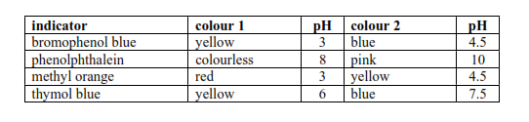

Hydrochloric acid has a pH of 1.0 and ethanoic acid has a pH of 5.0
Ammonia solution has a pH of 10.0 and sodium hydroxide has a pH of 12.5

- Complete the table below to show colours of the indicators in the solutions.

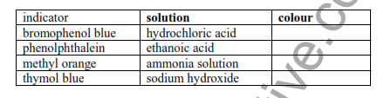

- Name one indicator which turns the same colour in both ethanoic acid and sodium hydroxide

………………………………………………………………………………………………………………………………………………………………………………………………………………………………………………………………………………………………………..

- Which two indicators turn the same colour in hydrochloric acid?
…………………………………………………………………………………………………………………………………………………………………………………………………………………………………..

QUESTIONSHEET 6
In an experiment ammonia solution, an alkali, was added to nitric acid.
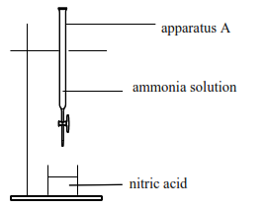

- What is the name of apparatus A?

……………………………………………………………………………………………………………………………………………………………………………………………………………………………………
- What is the name of the reaction when the acid reacts with the alkali?

………………………………………………………………………………………………………………………………………………………………………………………………………………………………………………………………………………………………………..
- What is the pH when just enough ammonia solution is added to react with all the nitric acid?

………………………………………………………………………………………………………………………………………………………………………………………………………………………………………………………………………………………………………..
- What is the ion which is present in any solution of acid?

……………………………………………………………………………………………………………………………………………………………………………………………………………………………………

- What is the ion which is present in any solution of alkali?
…………………………………………………………………………………………………………………
- Write the simplest ionic equation which represents the above reaction
……………………………………………………………………………………………………………………………………………………………………..............................................................................................

- The following label is found on the bottle containing the nitric acid.

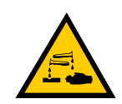

- What does the label tell you about the nitric acid?

…………………………………………………………………………………………………………………………………………………………………………………………………………………………………………………………………………………………………..
- Suggest two precautions which should be taken when using the nitric acid in the experiment
…………………………………………………………………………………………………………………………………………………………………………………………………………………………………..

