Class : 9
Subject : Chemistry
Topic : Acids ,Bases And Oxides
Teacher :Zubaida Aslam

Acids, Bases And Oxides

Q1. A student adds aqueous sodium hydroxide from a burette into 25.0 cm3 of dilute sulphuric acid. The student measures the pH value of the mixture during the addition of the sodium hydroxide.
(a) Describe how the pH value changes.
(b) Give an ionic equation to represent the neutralisation reaction between sodium hydroxide and sulphuric acid.
(c) Sulphuric acid is a strong acid.
(i) What is meant by the term acid?
(ii) What is the difference between a strong acid and a weak acid?
(d) Dilute sulphuric acid reacts with magnesium to give hydrogen.
Give the ionic equation for this reaction.
(e) Construct an equation for the reaction between Copper(II) Crbonate and sulfuric acid.

Q2. This question is concerned with the following oxides.
aluminium oxide
carbon monoxide
copper(II) oxide
silicon(IV) oxide
sodium oxide
sulfur dioxide
zinc oxide
Choose one oxide from the above list to match each of the following descriptions. An oxide may be used once, more than once or not at all.
(a) This oxide does not react with acid or alkali.
(b) This oxide reacts with water to give a strong alkali solution.
(c) This oxide is used as a bleach (d) This oxide is amphoteric.
(e) This oxide has a giant covalent structure.
(f) This oxide is soluble in water and it is acidic..Which row correctly classifies the oxides in the table?
Q3.Which row correctly classifies the oxides in the table?

 | Carbon dioxide | Copper(II)Oxide | Zinc Oxide
A  B  C  D | Acidic  Acidic  Acidic  Basics | Amphoteric  Basic  Neutral  Neutral | Basic  Amphoteric  Amphoteric  Neutral
Q4.Boron oxide B₂0₃ is an acidic oxide.state two inferences you can make from this ststement

Q5.This table shows the soil pH ranges required by different crops for growth.
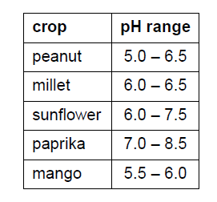

(a) A farmer plants peanut and millet crops. Only the peanut crop grows well.
Predict the pH of the soil.
(b) Which other crop is most likely to grow well in the same soil?
(c) The farmer adds calcium hydroxide, Ca(OH)2, and ammonium sulphate, (NH4)2SO4, to
the soil. Explain the purpose of using each compound.
(d) A reaction occurs between calcium hydroxide and ammonium sulphate.
Complete the equation for this reaction.
Ca(OH)2 + (NH4)2SO4 …………………… + …………………… + 2H2O

Q6.Sulfuric acid reacts with the alkali sodium hydroxide.
H2SO4 + 2NaOH Na2SO4 + 2H2O
(a) Write the ionic equation for this reaction.
...............................................................................................................................................[1]
(b) The graph below shows how the pH changes when aqueous sulfuric acid is added slowly to sodium hydroxide until the acid is in excess.

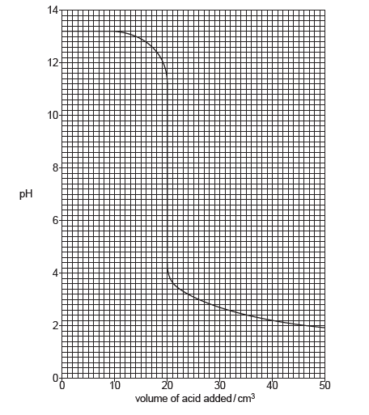

What volume of acid has been added when the pH is 7?

(c) The experiment was repeated using ethanoic acid of the same concentration as the sulfuric acid. The same volume and concentration of aqueous sodium hydroxide was used.
(i) The volume of ethanoic acid required to neutralise the aqueous sodium hydroxide was
twice as great compared with the volume of sulfuric acid. Explain why.
(ii) Suggest the value of the pH after excess ethanoic acid has been added.

