The City School
North Nazimabad Boys Campus
Date: 10-09-2016
Class: 9th
Subject: Add.Math
Teacher: Sheema Aftab

Explanation of Logarithms

Introduction to Logarithms
In its simplest form, a logarithm answers the question:
How many of one number do we multiply to get another number?
Example: How many 2s do we multiply to get 8?
Answer: 2 × 2 × 2 = 8, so we needed to multiply 3 of the 2s to get 8
So the logarithm is 3

How to Write it
We write "the number of 2s we need to multiply to get 8 is 3" as:
log₂(8) = 3
So these two things are the same:
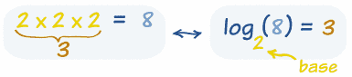
The number we are multiplying is called the "base", so we can say:
- "the logarithm of 8 with base 2 is 3"
- or "log base 2 of 8 is 3"
- or "the base-2 log of 8 is 3"

Notice we are dealing with three numbers:
- the base: the number we are multiplying (a "2" in the example above)
- how many times to use it in a multiplication (3 times, which is the logarithm)
- The number we want to get (an "8")

More Examples

Example: What is log₅(625) ... ?
We are asking "how many 5s need to be multiplied together to get 625?"
5 × 5 × 5 × 5 = 625, so we need 4 of the 5s
Answer: log₅(625) = 4

Example: What is log₂(64) ... ?
We are asking "how many 2s need to be multiplied together to get 64?"
2 × 2 × 2 × 2 × 2 × 2 = 64, so we need 6 of the 2s
Answer: log₂ (64) = 6
Exponents
Exponents and Logarithms are related, let's find out how ...
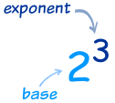 | The exponent says how many times to use the number in a multiplication.  In this example: 2³ = 2 × 2 × 2 = 8  (2 is used 3 times in a multiplication to get 8)
So a logarithm answers a question like this:
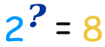
In this way:
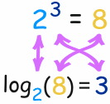
The logarithm tells us what the exponent is!
In that example the "base" is 2 and the "exponent" is 3:
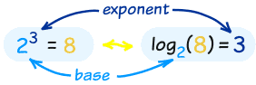
So the logarithm answers the question:
What exponent do we need
(for one number to become another number) ?
The general case is:
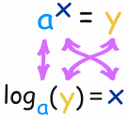
Example: What is log₁₀(100) ... ?
10² = 100
So an exponent of 2 is needed to make 10 into 100, and:
log₁₀(100) = 2
Example: What is log₃(81) ... ?
3⁴ = 81
So an exponent of 4 is needed to make 3 into 81, and:
log₃(81) = 4

Common Logarithms: Base 10
Sometimes a logarithm is written without a base, like this:
log(100)
This usually means that the base is really 10.
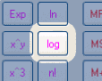
It is called a "common logarithm". Engineers love to use it.
On a calculator it is the "log" button.
It is how many times we need to use 10 in a multiplication, to get our desired number.
Example: log(1000) = log₁₀(1000) = 3
Natural Logarithms: Base "e"
Another base that is often used is e (Euler's Number) which is about 2.71828.
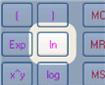
This is called a "natural logarithm". Mathematicians use this one a lot.On a calculator it is the "ln" button.It is how many times we need to use "e" in a multiplication, to get our desired number.
Example: ln(7.389) = log_{e}(7.389) ≈ 2
Because 2.71828² ≈ 7.389
But Sometimes There Is Confusion ... !
Mathematicians use "log" (instead of "ln") to mean the natural logarithm. This can lead to confusion:
Example | Engineer Thinks | Mathematician Thinks
log(50) | log₁₀(50) | log_{e}(50) | confusion
ln(50) | log_{e}(50) | log_{e}(50) | no confusion
log₁₀(50) | log₁₀(50) | log₁₀(50) | no confusion
So, be careful when you read "log" that you know what base they mean!
Logarithms Can Have Decimals
All of our examples have used whole number logarithms (like 2 or 3), but logarithms can have decimal values like 2.5, or 6.081, etc.
Example: what is log₁₀(26) ... ?
Get your calculator, type in 26 and press log
Answer is: 1.41497...
The logarithm is saying that 10^{1.41497...} = 26
(10 with an exponent of 1.41497... equals 26)
This is what it looks like on a graph:  See how nice and smooth the line is. |  | 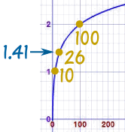
Read Logarithms Can Have Decimals to find out more.
Negative Logarithms
Negative? But logarithms deal with multiplying.
What could be the opposite of multiplying? Dividing!

A negative logarithm means how many times to divide by the number.
We could have just one divide:
Example: What is log₈(0.125) ... ?
Well, 1 ÷ 8 = 0.125,
So log₈(0.125) = −1
Or many divides:
Example: What is log₅(0.008) ... ?
1 ÷ 5 ÷ 5 ÷ 5 = 5⁻³,
So log₅(0.008) = −3

It All Makes Sense
Multiplying and Dividing are all part of the same simple pattern.
Let us look at some Base-10 logarithms as an example:
 | Number | How Many 10s | Base-10 Logarithm
 | .. etc..
 | 1000 | 1 × 10 × 10 × 10 | log₁₀(1000) | = 3
 | 100 | 1 × 10 × 10 | log₁₀(100) | = 2
 | 10 | 1 × 10 | log₁₀(10) | = 1
 | 1 | 1 | log₁₀(1) | = 0
 | 0.1 | 1 ÷ 10 | log₁₀(0.1) | = −1
 | 0.01 | 1 ÷ 10 ÷ 10 | log₁₀(0.01) | = −2
 | 0.001 | 1 ÷ 10 ÷ 10 ÷ 10 | log₁₀(0.001) | = −3
 | .. etc..
Looking at that table, see how positive, zero or negative logarithms are really part of the same (fairly simple) pattern.

