The City School
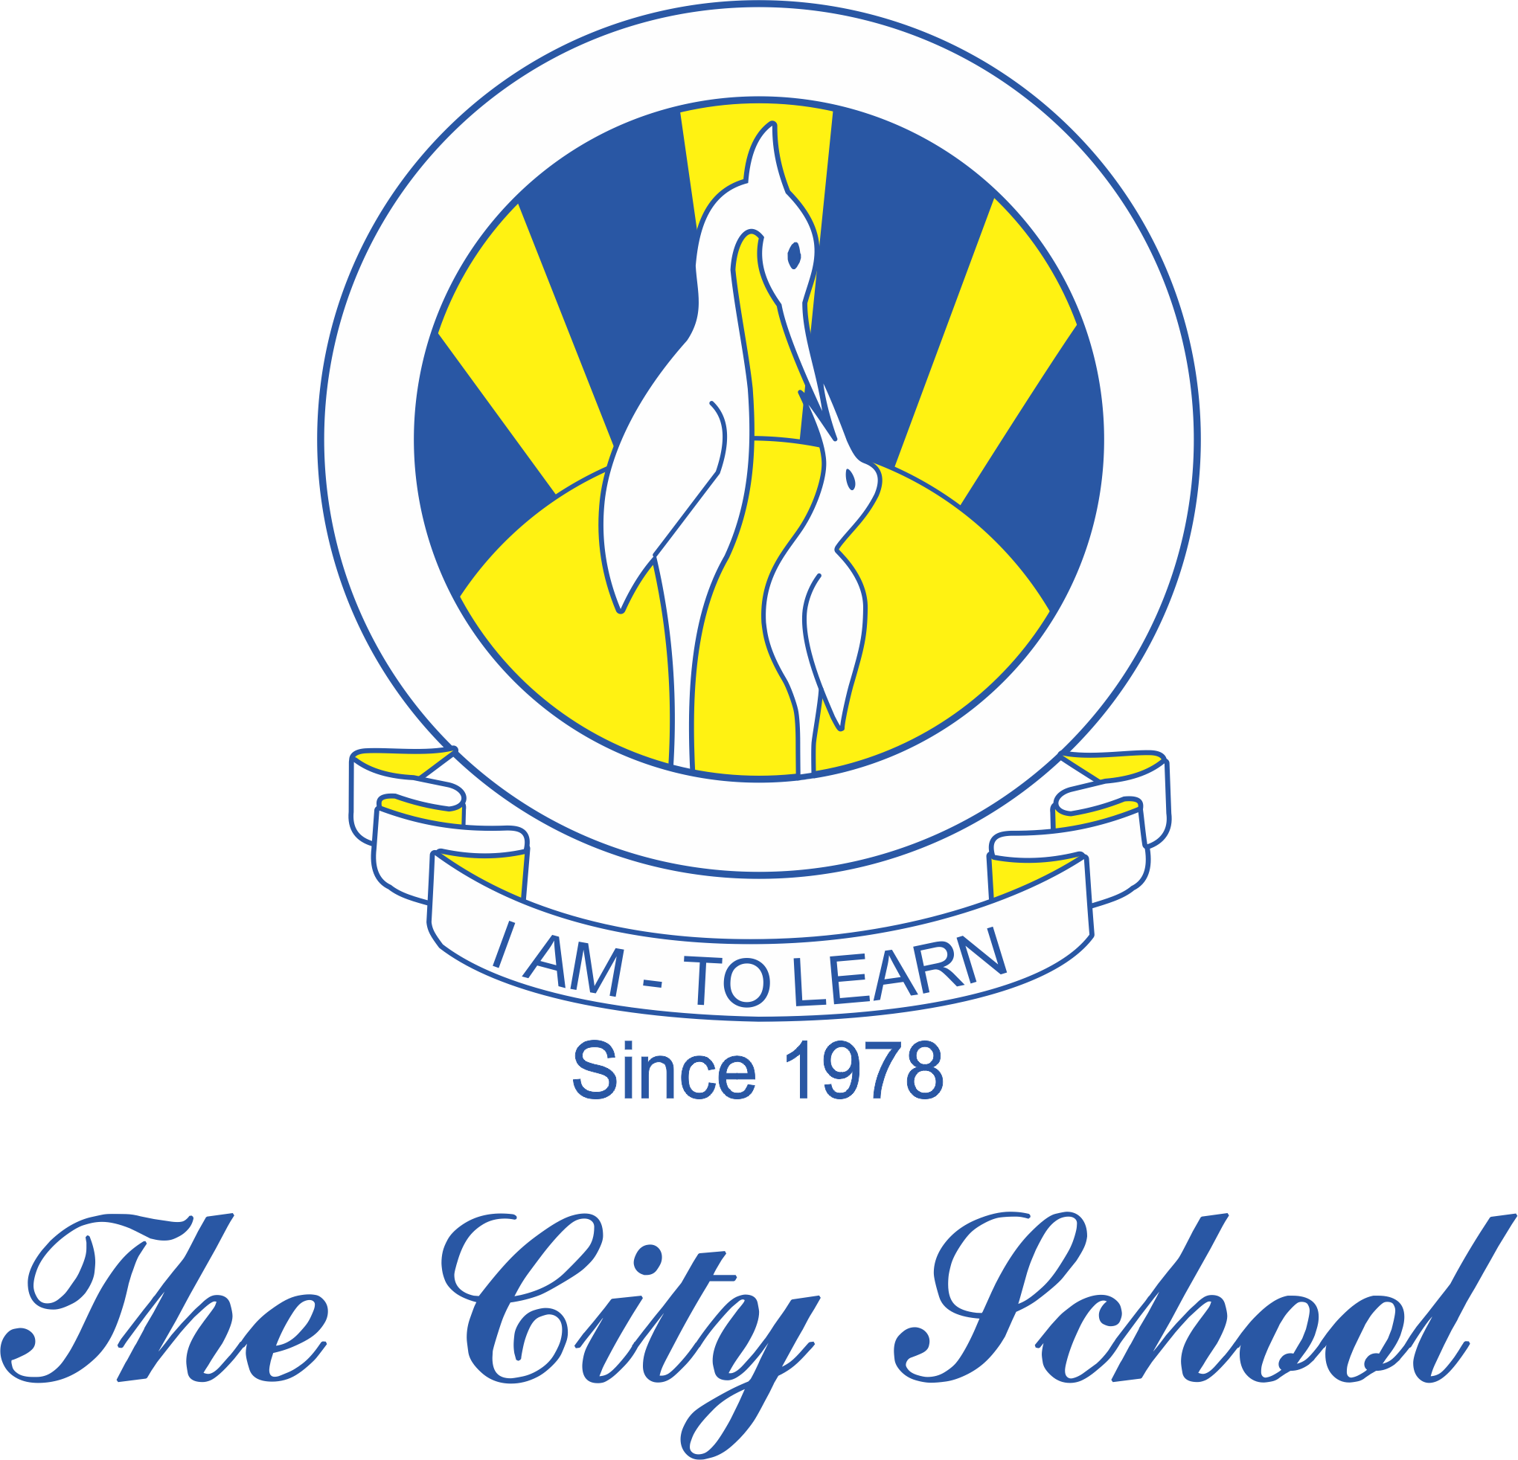
North Nazimabad Boys Campus
Consolidated Syllabus for Grade 9 EOY 2018 - 19
Add Math

- Simultaneous Equations
- Indices, Surds and Logarithms
- Quadratic equations and expressions
- Remainder and Factor Theorems
- Coordinate Geometry

