O LEVEL CHEMISTRY 5070 ALCOHOLS AND CARBOXYLIC ACIDS

WORKSHEET 1
- The alcohols form an homologous series.

- Give three characteristics of an homologous series.

…………………………………………………………………………………………………………………………………………………………………………………………………………………………………………………………………………………………………………………………………………………………………………………………………………………………………………………………………[3]

- The following two alcohols are members of an homologous series and they are isomers

- Explain why they are isomers.

………………………………………………………………………………………………………………………………………………………………………………………………………………………………………………………………………………………………………………………………………………………………………………………………………………………………………………..[2]

- Deduce the structural formula of another alcohol which is also an isomer of these
alcohols.

[2]

  - Copper(II) oxide can oxidise butanol to liquid X, whose pH is 4.

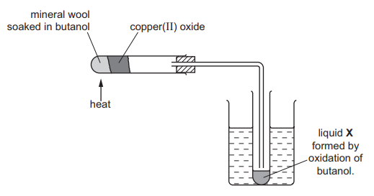

  - Give the name of another reagent which can oxidise butanol.

…………………………………………………………………………………………… [1]

  - Which homologous series does liquid X belong to?

……………………………………………………………………………………………………[1]

  - State the formula of liquid X.

……………………………………………………………………………………………… [1]

  - The alcohol ethanol can be made by fermentation. Yeast is added to aqueous glucose.

C6H12O6(aq) → 2C2H5OH(aq) + 2CO2(g)

Carbon dioxide is given off and the mixture becomes warm, as the reaction is exothermic.
The graph shows how the rate of reaction varies over several days.

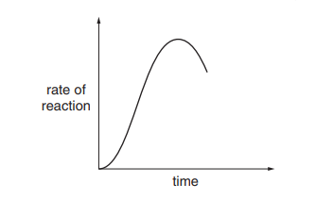

  - Suggest a method of measuring the rate of this reaction.

……………………………………………………………………………………………………………………………………………………………………………………………………………………………………………………………………………………………………………………………………………………………………………………………..[4]

  - Why does the rate initially increase?

…………………………………………………………………………………………………………………………………………………………………………………………………………………………………………………………………………………………………………………………………………………………………………………………………………………………………………………….[1]

  - Suggest two reasons why the rate eventually decreases

………………………………………………………………………………………………………………………………………………………………………………………………………………………………………………………………………………………………………………………………………………………………………………………………………………………………………………[2]

- Esters, polyesters and fats all contain the ester linkage.

Esters can be made from alcohols and carboxylic acids. For example, the ester ethyl ethanoate can be made by the following reaction.

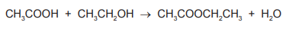
[1]

- Name the carboxylic acid and the alcohol from which the following ester could be made.
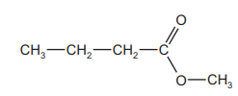

……………………………………………………………………………………………………………………………………………………………………………..[2]

- 6.0 g of ethanoic acid, Mr = 60, was reacted with 5.5 g of ethanol, Mr = 46.
Determine which is the limiting reagent and the maximum yield of ethyl ethanoate, Mr = 88.

- number of moles of ethanoic acid = .............................................................................. [1]

- number of moles of ethanol = ....................................................................................... [1]

- the limiting reagent is .................................................................................................... [1]

- number of moles of ethyl ethanoate formed = .............................................................. [1]

- maximum yield of ethyl ethanoate = ............................................................................. [1]

- The following two monomers can form a polyester

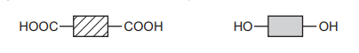

[2]

- Draw the structural formula of this polyester. Include two ester linkages.

Fats and vegetable oils are esters. The formulae of two examples of natural esters are given
below.

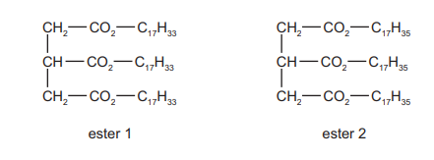

- Identify which ester is unsaturated?

……………………………………………………………………………………………………………………………[1]

- Describe a test to distinguish between them.

test ......................................................................................................................................

result with unsaturated ester ..............................................................................................

.............................................................................................................................................

result with saturated ester ..................................................................................................

.............................................................................................................................................

- Both esters are hydrolysed by boiling with aqueous sodium hydroxide.
What types of compound are formed?

............................................................... and .............................................................. [2]

- The ester linkage showing all the bonds is drawn as

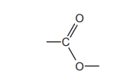

or more simply it can be written as –COO–.

- Give the structural formula of the ester ethyl ethanoate

[2]

- Deduce the name of the ester formed from methanoic acid and butanol.

.............................................................................................................................. [1]

- Which group of naturally occurring compounds contains the ester linkage?

.............................................................................................................................. [1]

- Draw the structural formula of the polyester formed from the following monomers.

HOOCC6H4COOH and HOCH2CH2OH

You are advised to use the simpler form of the ester linkage.

[2]

- Esters can be used as solvents in chromatography. The following shows a chromatogram of plant acids.
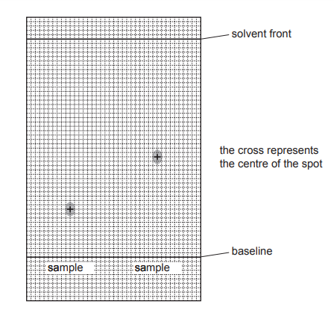

An ester was used as the solvent and the chromatogram was sprayed with bromothymol
blue.

- Suggest why it was necessary to spray the chromatogram.

....................................................................................................................................

.............................................................................................................................. [2]

- Explain what is meant by the Rf value of a sample.

....................................................................................................................................

.............................................................................................................................. [1]

- Calculate the Rf values of the two samples and use the data in the table to identify
the plant acids

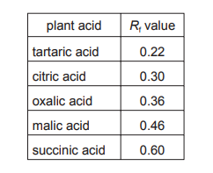

Sample 1 …………………….Rf value ………………. Its …………………….acid
Sample 2 ……………………Rf value…………………its……………………..acid

