The City School

North Nazimabad Boys Campus

Topic : Solutions Quadratic Word Problems

Teacher: Ms Sheema

Class 9
sAns1: Determine the quadratic equation whose solutions are: 3 and −2.
S = 3 − 2 = 1
P = 3 · 2 = 6
x² − x + 6 = 0
ans 2:Factor:
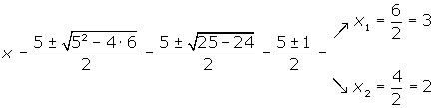
Ans 3:Determine the value of k so that the two roots of the equation x² − kx + 36 = 0 are equal.
b² − 4ac = 0
k² − 4 · 36 = 0 k² = 144
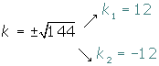
Ans 4: The sum of two numbers is 5 and their product is −84. Find these numbers.
x² − Sx + P = 0
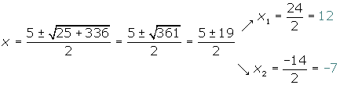
Ans 5:Within 11 years, the age of Peter will be half the square of the age he was 13 years ago. Calculate the current age of Peter.
Current age x
Age 13 years ago x − 13
Age within 11 years x + 11
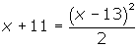
Current age 21
Ans6: To fence a rectangular farm of 750 m², 110 m of fence has been used. Calculate the dimensions of the farm.
Semiperimeter 55
Base x
Height 55 − x
x · (55 − x) = 750
x² − 55x + 750 = 0
x = 25 x = 30
The dimensions of the farm are 30 m and 25 m.

Ans7: The three sides of a right-angled triangle are proportional to the numbers 3, 4 and 5. Find the length of each side knowing that the area of the triangle is 24 m².
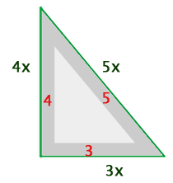
1st side (base) 3x
2nd side (height) 4x
3rd side 5x
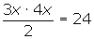
1st side 6 m
2nd side 8 m
3rd side 10 m
Ans 8: A rectangular garden 50 m long and 34 m wide is surrounded by a uniform dirt road. Find the width of the road if the total area of the garden and road is 540 m².
(50 + 2x) · (34 + 2x) − 50 · 34 = 540
4x² + 168x − 540 = 0 x² + 42x − 135 = 0
x = 3 and x = −45
The road width is 3 m .
Ans9: Calculate the dimensions of a rectangle whose diagonal is 75 m, knowing that it is similar to a rectangle with sides measuring 36 m 48 m respectively.
Base 48x : 12 = 4x
Height 36x : 12 = 3x
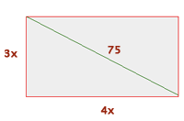
(4x)² + (3x)² = 75²
25x² = 5625
x² = 225 x = 15
Base 4 · 15 = 60 m
Height 3 · 15 = 45 m
Ans10: Find an integer number where the sum with its inverse is .
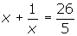
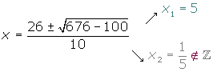
Ans11: Two natural numbers differ by two units and the sum of their squares is 580. What are these numbers?
1st number x
2nd number x + 2
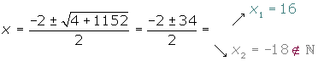
1st number 16
2nd number 18
Ans12: Two taps A and B fill a swimming pool together in two hours. Alone, it takes tap A three hours less than B to fill the same pool. How many hours does it take each tap to fill the pool separately?
Time of A x
Time of B x + 3
A
B 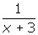
A and B
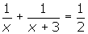
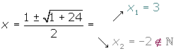
Time of A 3 hours

Time of B 6 hours
Q13: The length of the sides of a right-angled triangle are measured as three consecutive even numbers (in cm). Find the values of these sides.
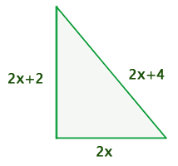
1st leg 2x
2nd leg 2x + 2
Hypotenuse 2x + 4
(2x)² + (2x + 2)² = (2x + 4)²
4x² + 4x² + 8x + 4 = 4x² + 16x + 16
4x² − 8x − 12 = 0 x² − 2x − 3 = 0
x = 3 y x= −1
1st leg 6 cm
2nd leg 8 cm
Hypotenuse 10 cm
Ans14: A rectangular piece of cardboard is 4 cm longer than wide. A box of 840 cm³ is constructed by using this piece of cardboard. A square of 6 cm is cut out in every corner and the rims are folded upwards to create the box. Find the dimensions of the box.
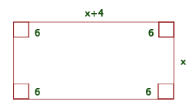
6 (x − 12) · (x + 4 −12) = 840 (x − 12) · (x −8) = 140
x² − 20x − 44 = 0 x = 22 y x= −2
The dimensions are: 26 cm and 22 cm.
Ans15: 2 faucets can fill a tank in 1 hour and 20 minutes. The first faucet takes more than two hours longer to fill the same tank when functioning without the second tap. How long does it take to fill each one separately?
1st Time x
2nd Time x − 2
1º
2º 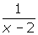
Between the two
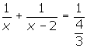
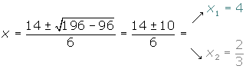
1st Time 4 hours
2nd Time 2 hours
is not a solution because the time for the second faucet would be negative.

