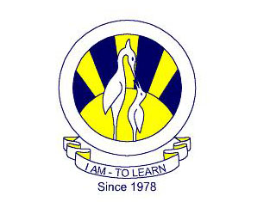 **The City School**

**North Nazimabad Boys Campus**

**ATP CHEMISTRY WORKSHEET**

**Class: 10  
Subject: Chemistry  
Teacher: Uzma Amer**

