Topic: Bearing

1. In the diagram, the bearing of B from A is 064˚, AĈB=70˚ and AB=BC. Calculate
(a) The bearing of A from B,
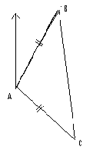
(b) $∠ABC$,
(c) The bearing of C from B.

2. The bearing of B from A is 031 ̊, the bearing of C
From A is 129˚ and AB=AC calculate
(a) The bearing of A from B,
(b) $∠$ ACB,
(c) The bearing of C from B

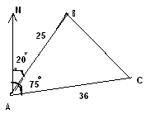

3. in the diagram, A, B and C represent three islands.
B is 25km from A on a Bearing of 020˚.
C is 36 km from A on a bearing of 075˚.
(a) Calculate the bearing of A from B.
(b) Calculate the distance of C from B.
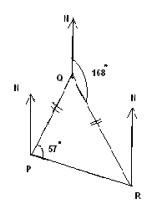

4. P, Q and R three towns. Q is equidistance from P and R.
The bearing of R from Q is 168˚ and QPR=57˚,
Find
(a) The reflex angle RPQ,
(b) The acute angle PQR,
(c) The bearing of Q from R,
(d) The bearing of Q from P.

5. P, Q and R are the three points on level ground. Given that the bearing of R from
P is 135˚.$∠$Q=55˚ and ˚.$∠R$=48˚.calculate the bearing of
(a) P from R (b) Q from R (c) P from Q

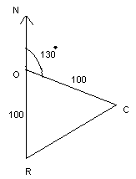
6. A point P is 12 km due to north of another point Q.the bearing of a lighthouse from P is 135˚ and Q it is 120˚. Calculate the distance of PR.

7. An island R is 100 km due to south of the port O. Calculate the bearing of R from C.

8. The diagram shows the A, B, C and D, the four corners of a horizontal rectangular
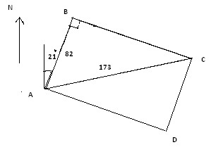
Field ABCD.The corner B is 82 meters from A on a bearing of 021˚ and C is
173 meters from A.
Calculate
(a) The bearing of C from B,
(b) BÂC
(c) The bearing of C from A.

