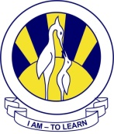
The City School
North Nazimabad Boys Campus

Date: 23-09-2015
Subject: Biology
Class: 10
Teacher: Humaira

1.EXCRETION
2.HOMEOSTASIS
3.NERVOUS SYSTEM
4.SENSE ORGAN
5.ENDOCRINE SYSTEM
6.SUPPORT,MOVEMENT AND LOCOMOTION

