BLOG WORKSHEET
BIOLOGY CLASS 9

Teacher Name: Uzma Amer Class: 9 Biology Date: 16th March’18

TRANSPORT IN HUMAN BEING

Figure1: Shaded areasare muscle; unshaded areasarefilled withblood.

Figure1
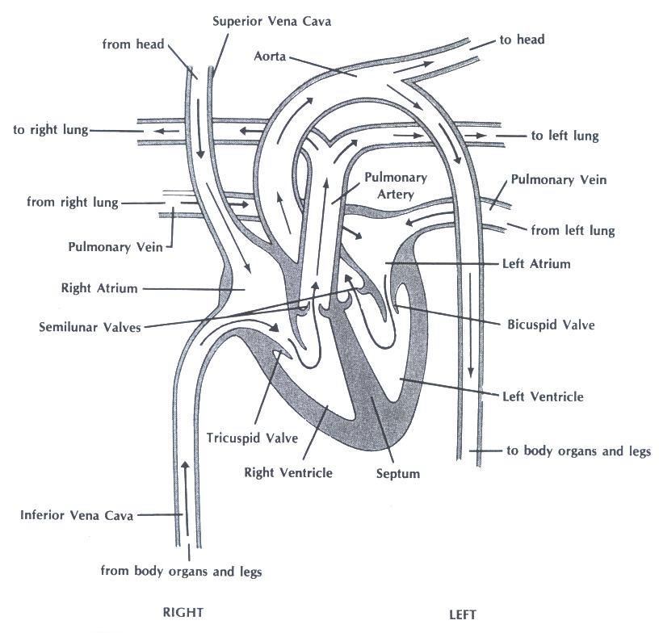

Q.1.Answer the following questions:

- The two receiving chambers for blood are the

- The two discharging chambers for blood are the

- The separates heart chambers.

- The LEFT side of the heart RECEIVES Blood FROM the _____________

- The RIGHT side of the heart RECEIVES blood FROM the
___________________
- The LEFT side of the heart PUMPS blood To the_____________

- The RIGHT side of the heart PUMPS blood TO the
_________

In the table below, fill in whether the heart chamber/blood vessel listed contains oxygenated/deoxygenated blood

HeartChamberorBloodVessel | Oxygenated(O)/ Deoxygenated(D)
Left Ventricle
Right Ventricle
Left Atrium
Right Atrium
Pulmonary Artery
Pulmonary Vein
Superior vena cava
Inferior vena cava
Aorta

Use the table above along with Figure1 to answer the following:

1. The blood in the LEFT side of the heart is oxygenated/deoxygenated. Why is this logical?

2. The blood in the RIGHT side of the heart is oxygenated/deoxygenated. Why is this logical

3. Blood is changed from an oxygenated state to a deoxygenated state OR from a deoxygenated state to an oxygenated state in our circulatory system. Which change occurs in the……

• Lung capillaries
Explain why:

• Body capillaries
Explain why:

4. Where does blood go AFTER it leaves the……

Right atrium
Aorta

Left atrium
Superiorvenacava

Right ventricle
Inferiorvenacava

Left ventricle
Lungs

Pulmonaryveins
Organs&legs

Pulmonaryarteries
Head

5. Where did the blood come from BEFORE it entered the……

Right atrium
Aorta

Left atrium
Superiorvenacava

Right ventricle
Inferiorvenacava

Left ventricle
Lungs

Pulmonaryveins
Organs&legs

Pulmonaryarteries
Head

6. What could happen if a heart valve did not work properly?

