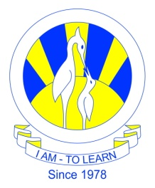
The City School
North Nazimabad Boys Campus
Syllabus For 3rd Monthly Test
Date: 9-11-2016
Subject: Biology
Class: 10
Teacher: Humaira Imran

- Suppor, movement and locomotion
- Endocrine system

