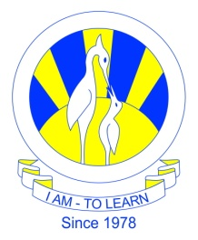
The City School
North Nazimabad Boys Campus
Syllabus For 3rd Monthly Test
Date: 9-11-2016
Subject: Biology
Class: 11
Teacher: Humaira Imran

1.Insect and wind pollinated flower
2.ATP food Test
3.ATP magnification
4.ATP Draw and label the diagram

