The City School
BLOG WORKSHEET
BIOLOGY CLASS 9

Teacher Name: Uzma Amer Class: 9 Biology Date: 25th Jan’19
Q.1. Choose the best answers.
- Where and how does carbon dioxide enter a plant?
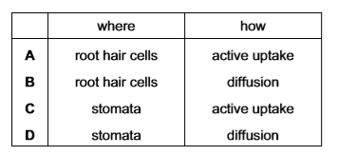
- The diagram shows the shapes of the cells in a section of a leaf.
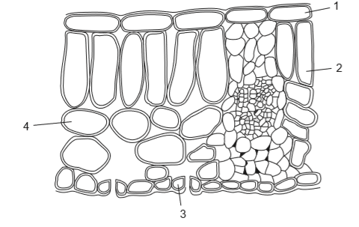
Which cells contain chloroplasts?
- 1 and 2
- 2 only
- 2 and 3 only
- 2, 3 and 4
- What are the functions of the xylem?
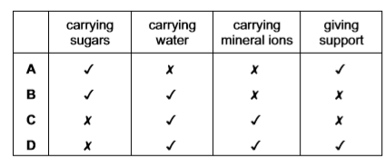

- Photosynthesis increases concentration of oxygen in air, which is necessary for all
- living organism
- fossils
- birds only
- animals
- Process of photosynthesis increases when light gets
- dim
- brighter
- off
- none of them
- Rate of photosynthesis is affected when temperature is too
- hot
- mild
- cold
- hot or cold
- Products of photosynthesis are oxygen and
- Starch and Sucrose
- Glucose
- Starch
- Water

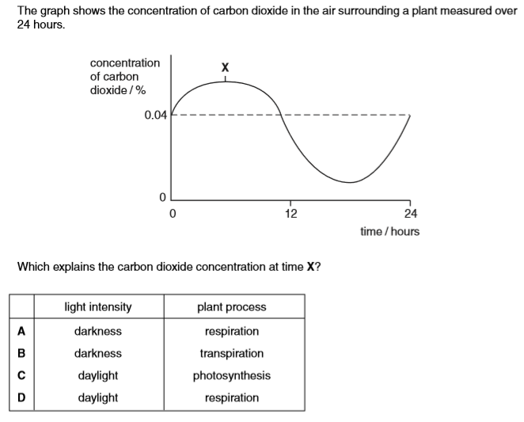

- Mesophyll tissues contain chlorophyll and proteins to carry out
- photosynthesis
- respiration
- transpiration
- none of them
- All animals need oxygen and most of this oxygen comes from
- roots
- plants
- stem
- pollen grain

