The City School
BLOG WORKSHEET
BIOLOGY CLASS 9

Teacher Name: Uzma Amer Class: 9 Biology Date: 2nd Feb’19
Q.1. Choose the best answers.
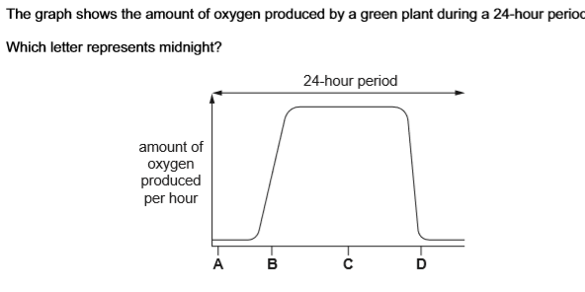

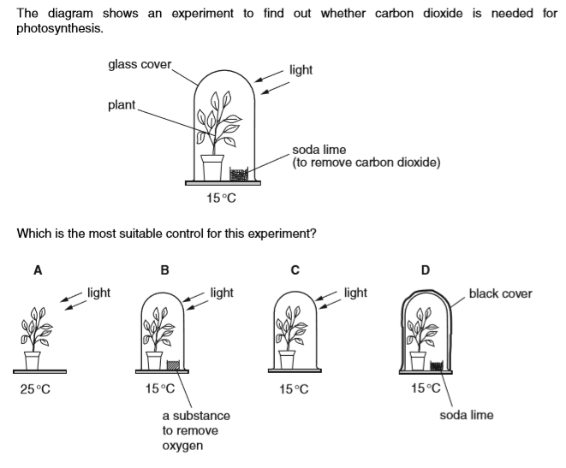

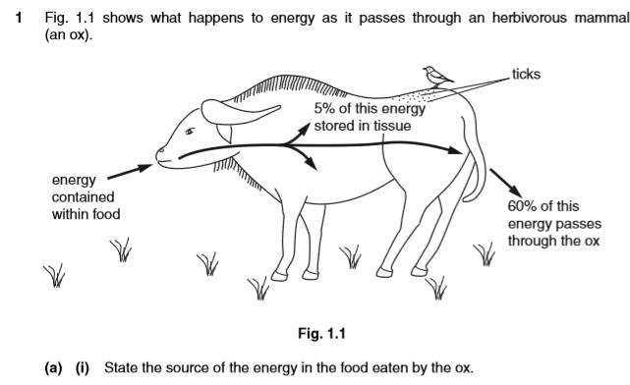
- State the source of the energy in the food eaten by the ox.
------------------------------------------------------------------------------------------------------
- State the form in which the energy is present in the carbohydrate eaten by the ox.
--------------------------------------------------------------------------------------------------------------------------------------------------------------------------------------------------------------
- Name the process that makes the remaining 35% of the energy in the food available to the ox.
-------------------------------------------------------------------------------------------------------
- State three ways in which the energy may be used within the ox.
1. ...............................................................................................................................
2. ...............................................................................................................................
3. ..........................................................................................................................

