BLOG WORKSHEET
BIOLOGY CLASS 9

Teacher Name: Uzma Amer Class: 9 Chemistry Date: 17th May’19
Q.1. Choose the best answers:
- The arrows show the movement of salts into a cell.

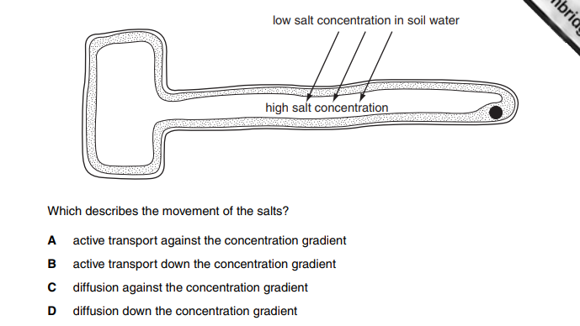
- As a seed begins to germinate, it uses enzymes to speed up the rate of
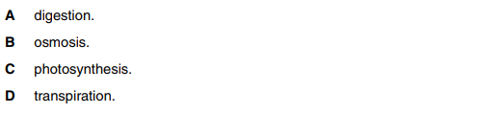

- Large, insoluble molecules have to be digested before they can be
- Absorbed.
- Assimilated.
- Egested.
- Ingested.
- The pH in the mouth decreases after eating. Which statement explains the decrease in pH?
A Bacteria release acids when respiring food substances.
B Enzymes in saliva release acids during digestion.
C Food substances become alkaline when chewed.
D Salivary glands release an alkaline solution.
- Cylinders of potato tissue were placed in different concentrations of sugar solution. The graph shows the percentage change in length of the cylinders of potato tissue.

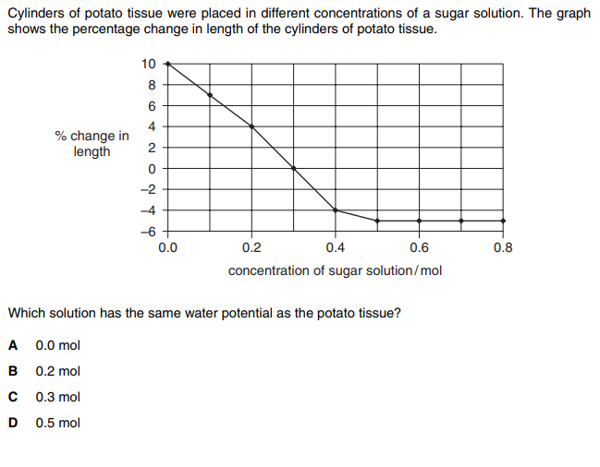

- Which conditions cause the fastest rate of transpiration?
A dry and cold
B dry and warm
C wet and cold
D wet and warm

- Where in the alimentary canal is most water absorbed?
- Colon
- Ilium
- Oesophagus
- Stomach
- Which food would be best for a person suffering from anaemia?
- Which is an example of active transport?
A. movement of glucose into the cells of the villi
B. movement of glucose molecules down a concentration gradient
C. movement of ions in blood plasma
D. movement of water in the transpiration stream

- What is the correct route for blood flow in a human?
A. left atrium → left ventricle → lungs → right ventricle → right atrium
B. left atrium → left ventricle → right ventricle → right atrium → lungs
C. right atrium → right ventricle → left ventricle → left atrium → lungs
D. right atrium → right ventricle → lungs → left atrium → left ventricle

- The diagram shows the human circulatory system.
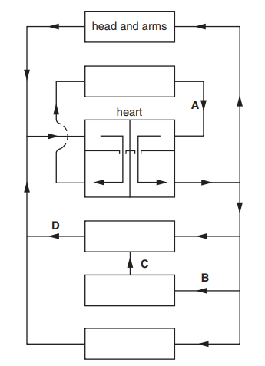

- Similar shaped pieces of potato are placed in sucrose solution of different concentrations. After three hours, the mass of each potato piece is measured.
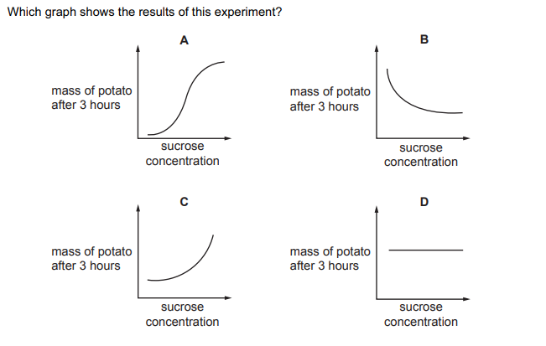

- When the skin is cut the blood clots.
In which order would the components of the blood become involved?
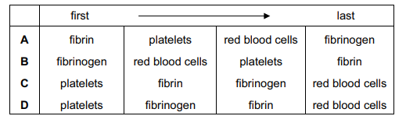
- A dish is filled with agar jelly contained starch. Four holes are cut in the jelly and each hole is filled with the different substances shown.
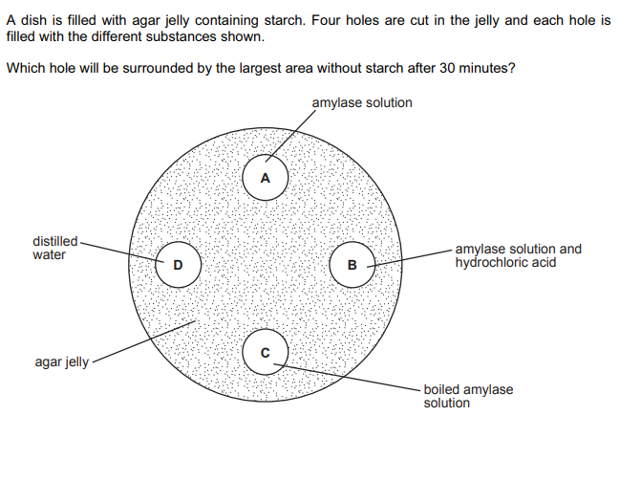
- A plant is kept in the dark for two days. A leaf is used in an experiment to investigate the effect of two factors on photosynthesis, as shown in the diagram.
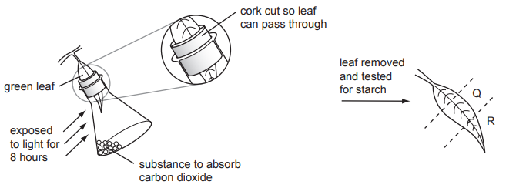
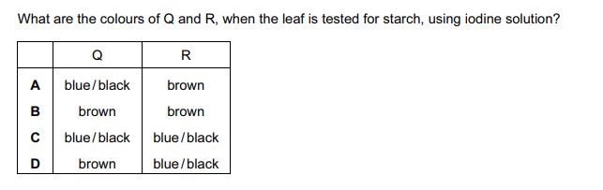
- The diagrams show the outlines of cells in two different views of leaf.
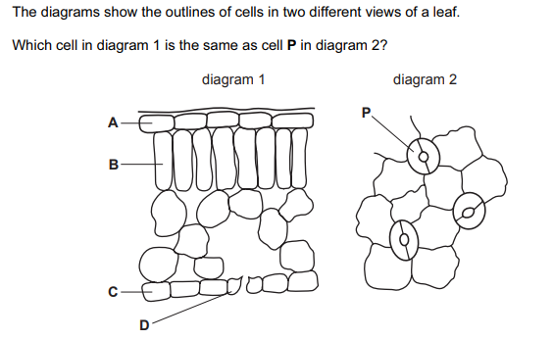

- The graph shows changes in a person’s pulse rate over period of 45 minutes
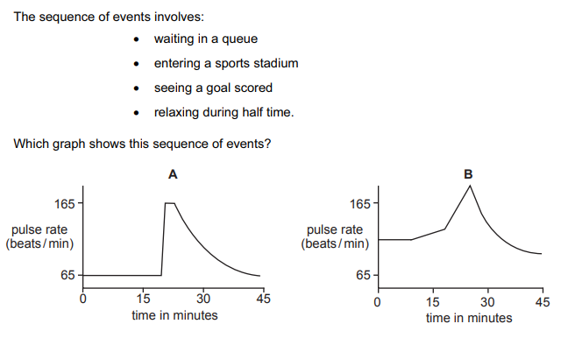
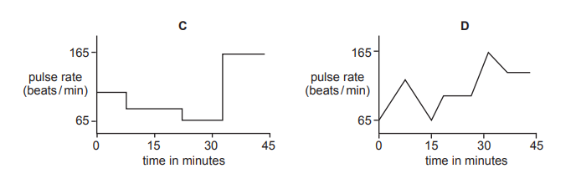
- Which statement about enzymes is essential to the lock and key hypothesis?
A Enzyme molecules are catalysts.
B Enzyme molecules can be damaged by high pH values.
C Enzyme molecules can be damaged by high temperatures.
D Enzyme molecules each have a distinct shape.
- Magnesium is an essential element for
A formation of cell walls.
B the formation of chlorophyll.
C the formation of proteins.
D the process of cell division.

- The diagram shows sections through the stem and root of a dicotyledonous plant
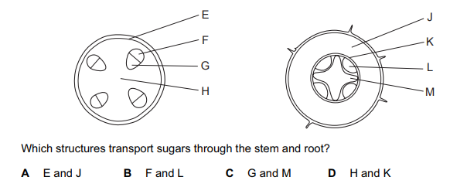
- Which adaptations of a root hair cell make it suitable for water uptake?
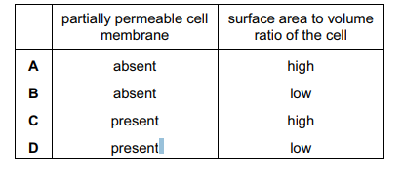
- The diagram shows the pressures in the left side of the heart during one heartbeat
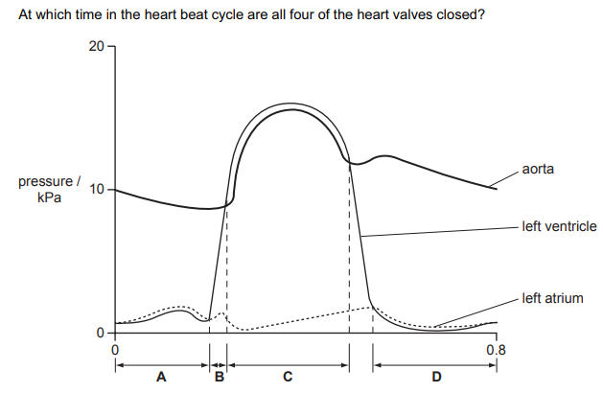
- After muscular exercise, which blood vessel carries the lowest concentration of carbon dioxide?
A hepatic artery
B pulmonary vein
C renal artery
D vena cava
- Which liquid has the highest water potential at atmospheric pressure?
A distilled water
B leaf cytoplasm
C root hair cell sap
D soil water
- The apparatus in the diagram is used to investigate whether carbon dioxide is given off by a green plant.
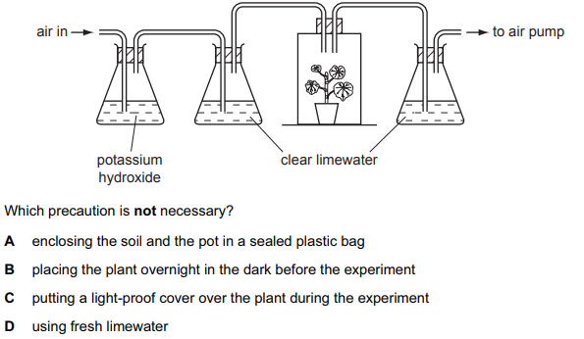
- What are the functions of the xylem?
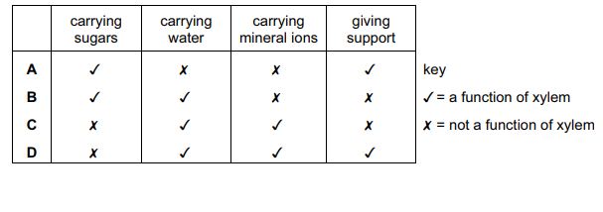
- The diagram represents a tissue with an adjacent capillary.
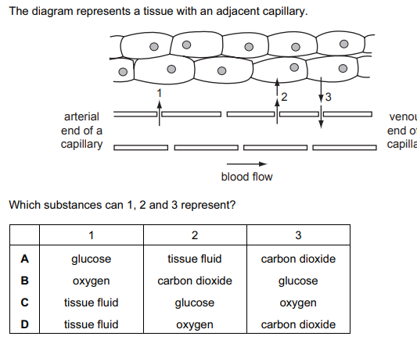
- A vein has a wider lumen than an artery. What is the advantage of this?
A bringing blood into close contact with the tissues
B offering less resistance to blood flow
C preventing back flow of blood
D resisting high blood pressure from the heart
- The elements, listed, are found in all living organisms. Which one is not obtained by plants from the soil?
A carbon
B iron
C magnesium
D nitrogen
- In the human circulatory system, what causes the transfer of materials from the capillaries to the tissue fluid?
A active transport
B blood pressure
C capillarity
D osmosis

