BLOG WORKSHEET
BIOLOGY CLASS 9

Teacher Name: Uzma Amer Class: 9 Chemistry Date: 17th May’19
Section A
Answer all questions in this section.
Write your answers in the spaces provided
1 Fig. 1.1 shows a plant in a beaker containing a solution of dye. Fig. 1.2 shows the tissues of the same plant as they would appear if a cross section is taken at X.
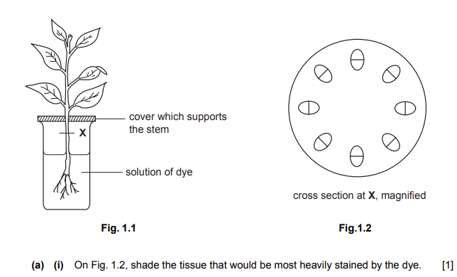
(ii) Name this tissue .............................................................................................................................[1]
(b) Explain the processes occurring in the plant that cause the dye to move upwards through the stem.
………………………………………………………………………………………………………………………………………………………………………………………………………………………………………………………………………………………………………………………………………………………………………………………………………………………………………………………………………………………………………….[3]
(c) Describe the process responsible for the uptake of the dye into the roots of the plant.
……………………………………………………………………………………………………………………………………………………………………………………………………………………………………………………………………………………………………………………………………………………………………………………………………………………………………………………………………………………………………………………………………………………………………………………………………………………………………………….[3]
(d) Suggest and explain what would happen to a plant if its roots are submerged in a concentrated salt solution for six hours
………………………………………………………………………………………………………………………………………………………………………………………………………………………………………………………………………………………………………………………………………………………………………………………………………………………………………………………………………………………………………………………………………………………………………………………………………………………………………………..[3]
[Total: 11]
2. (a) Name the mineral ion required for the manufacture of the pigment in red blood cells.
………………………………………………………………………………………………………………………………………………………..[1]
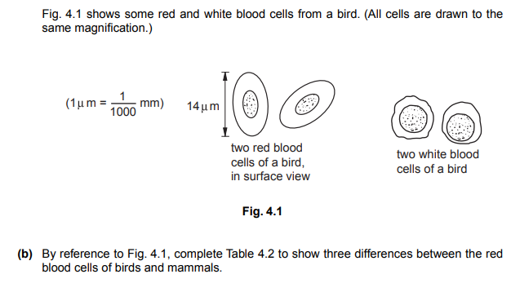
……………………………………………………………………………………………………………………………………………………………………………………………………………………………………………………………………………………………………………………………………………………………………………………………………….[3]
3. Fig. 1.1 shows a vertical section through a pair of guard cells and some other cells on the lower surface of a leaf.
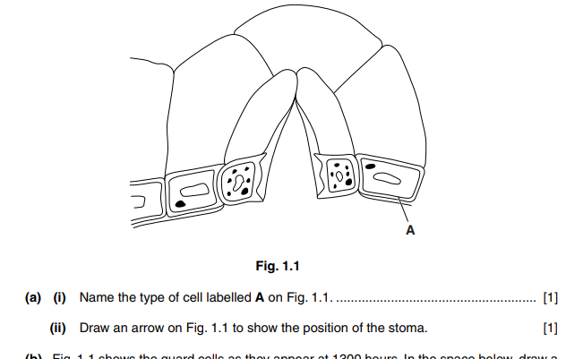
(b) Fig. 1.1 shows the guard cells as they appear at 1300 hours. In the space below, draw a diagram to show the guard cells, in surface view, as they would appear at 0100 hours.
On your diagram, draw and label the structural features of one of the guard cells.

[4]
4 Fig. 4.1 shows part of the circulatory system, and some of the structures associated with organ B
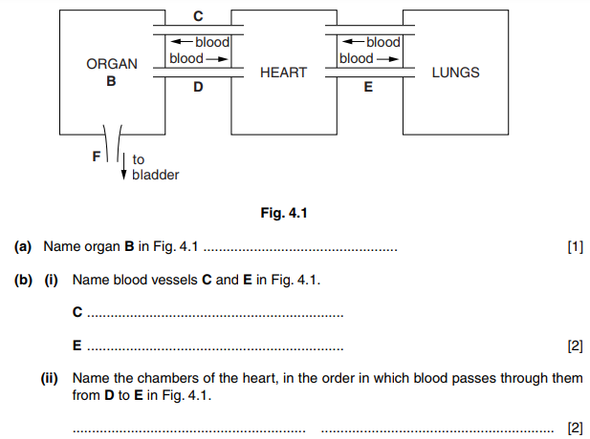
(c) Complete Table 4.1 to show four differences between the contents of F and the blood vessel, C, in a healthy person.
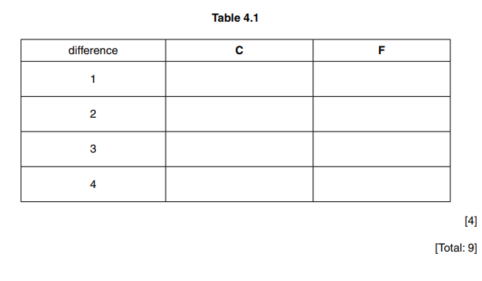
5 Fig. 5.1(a) and Fig. 5.1(b) show graphs of the pulse and breathing rates of two students, E and F, during and after one minute’s vigorous exercise.
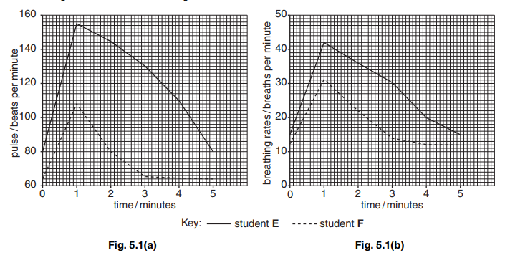
Fig. 5.1(a) Fig. 5.1(b) (a) State how long it took for student F’s pulse and breathing rates to return to their original levels after the student had finished exercising. pulse rate ................................................. breathing rate ........................................... [2]
(b) Explain why the pulse and breathing rates of both students increased during exercise. ................................................................................................................................................... ................................................................................................................................................... ................................................................................................................................................... ................................................................................................................................................... ...............................................................................................................................................[4]
(c) Suggest and describe possible reasons for the differences in the effect of vigorous exercise on these two students. ................................................................................................................................................... ................................................................................................................................................... ................................................................................................................................................... ................................................................................................................................................... ............................................................................................................................................[4] [Total: 10]
6. Using an example to illustrate each process, describe how substances move into and out of cells. ........................................................................................................................................... ........................................................................................................................................... ........................................................................................................................................... ........................................................................................................................................... ........................................................................................................................................... ........................................................................................................................................... ........................................................................................................................................... ........................................................................................................................................... ........................................................................................................................................... ........................................................................................................................................... ........................................................................................................................................... ........................................................................................................................................... ........................................................................................................................................... ........................................................................................................................................... ........................................................................................................................................... ........................................................................................................................................... ........................................................................................................................................... ........................................................................................................................................... ........................................................................................................................................... ........................................................................................................................................... ........................................................................................................................................... ........................................................................................................................................... ........................................................................................................................................... ........................................................................................................................................... ........................................................................................................................................... .....................................................................................................................................[10] [Total: 10]
7. (a) (i) State what is meant by transpiration. ........................................................................................................................................... ........................................................................................................................................... .......................................................................................................................................[3] (ii) Explain how the transpiration stream is important for the production of proteins in a plant. ........................................................................................................................................... ........................................................................................................................................... .......................................................................................................................................[2] (b) Describe and explain how tissues in the stem of a plant become stained when a plant is carefully removed from the soil and placed in a solution of dye for a few hours. ................................................................................................................................................... ................................................................................................................................................... ................................................................................................................................................... ................................................................................................................................................... ................................................................................................................................................... ................................................................................................................................................... ...............................................................................................................................................[5]
[Total: 10]

