BLOG WORKSHEET
CHEMISTRY CLASS 9

Teacher Name: Uzma Amer Class: 9 Biology Date: 13th Sep’19
Q.1. choose the best answers: Max. Marks: 10
- The diagram shows a typical plant cell after being placed in a concentrated salt solution for ten minutes.

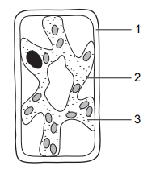
Which numbered structures are partially permeable?

A 1 and 2 only B 1 and 3 only C 1 only D 2 only

- What will happen to an animal cell placed in a salt water solution?
- The cell will shrink
- the cell will expand
- the cell will burst
- No change

- The diagram shows a plant cell. Which structure controls the passage of substances into and out of the cell?
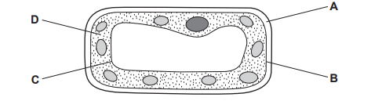
- Chamber A contains 40% helium and Chamber B contains 20% helium. Chambers are connected by a tube the molecules are free to cross. Which of the following will occur?
- some helium will move from chamber A to chamber B
- some helium will move from chamber B to chamber A
- helium will remain concentrated in chamber A
- all of the helium will move into chamber B
- The diagram represents a cell as seen under the electron microscope.
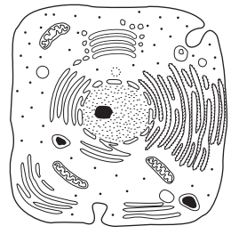
What type of cell is this?
 | Type of Cell | Reason
A  B  C  D | Animal cell  Bacterium  Plant cell  Plant cell | outer layer is the cell membrane  no chromosomes are visible  cytoplasm is visible  cell wall is visible

- Active transport requires:
- A concentration gradient
- Osmosis
- Energy
- A hypertonic solution
- The table shows the concentrations of some mineral ions in the root hair of a plant and in the soil around it.
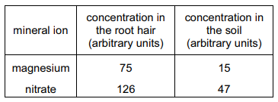
How are these mineral ions absorbed from the soil by the plant?
- An animal cell placed in a hypotonic solution will:
- Die
- take on water
- lose water
- divide

- The photomicrograph shows onion epidermis.

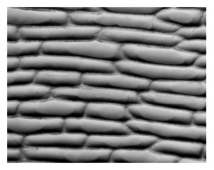

Which term describes this onion epidermis?

A cell B organ C organ system D tissue

- Which of these processes require energy from respiration?
