BLOG WORK
BIOLOGY CLASS 10
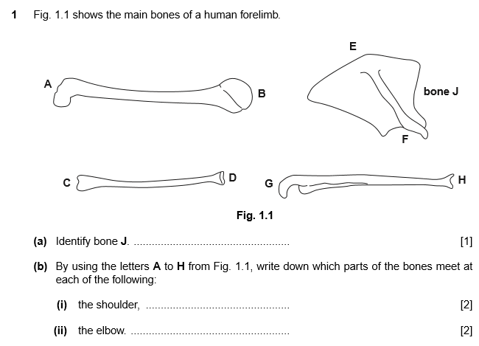
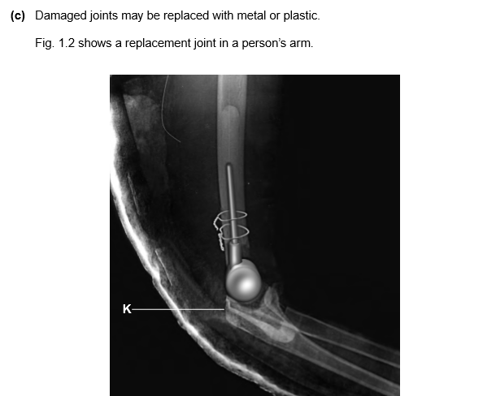
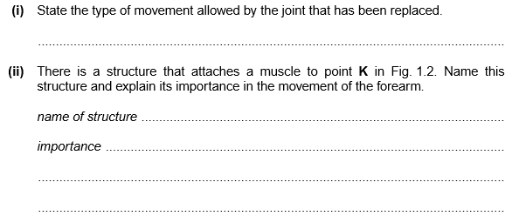
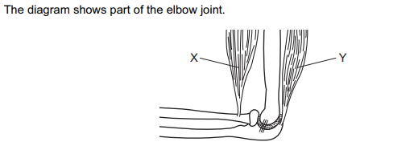
- Label X and Y
- Describe the function of those parts of elbow joints
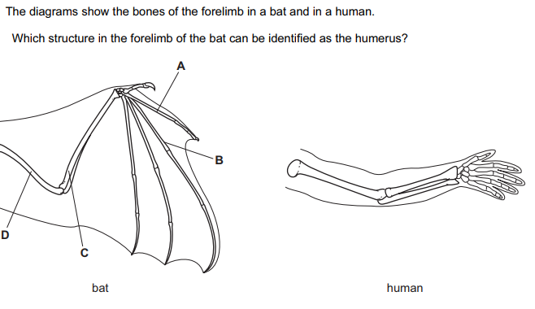

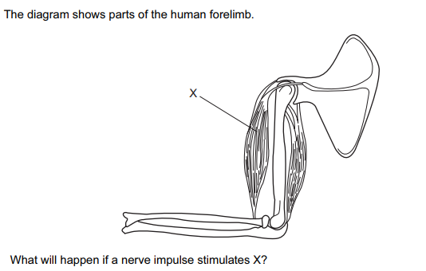
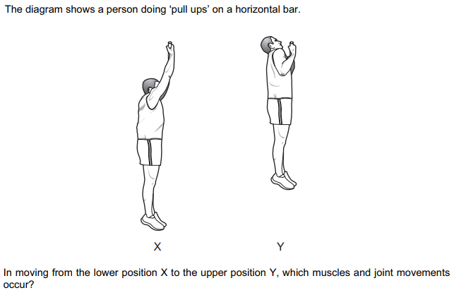

Q
- List down the bones of forelimb of human being.
- Discuss briefly the main function of skeleton
Q
- Define joints
- Classify various types of joints on the basis of mobility.
Q
- What are synovial joints?
- Describe different types of synovial joints.
- Name the fluid that is present between two joints.
- Differentiate between hinge joint and ball and socket joint.
Q
- State and explain the antagonistic muscles
- Give one example of antagonistic muscle
- Differentiate between extensor muscle and flexor muscle
Q Describe briefly the structure of:
- Hinge joints
- Ball and socket joint

