BLOG WORKSHEET
BIOLOGY CLASS 9
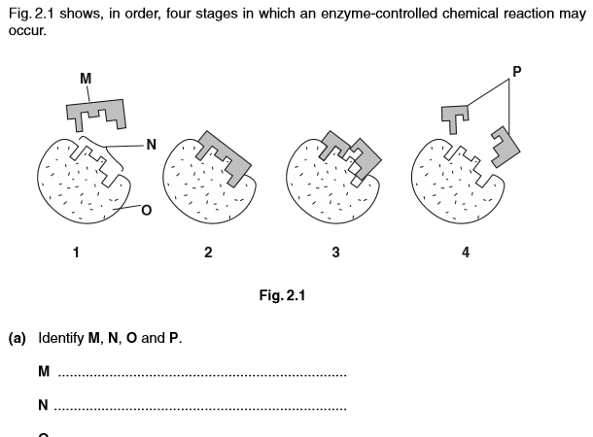
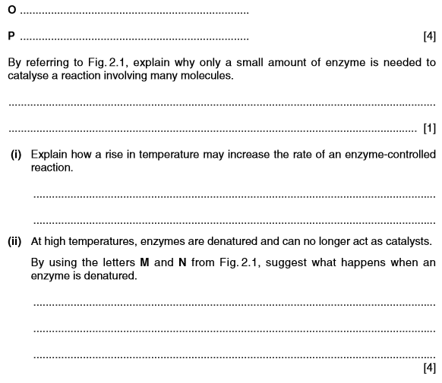

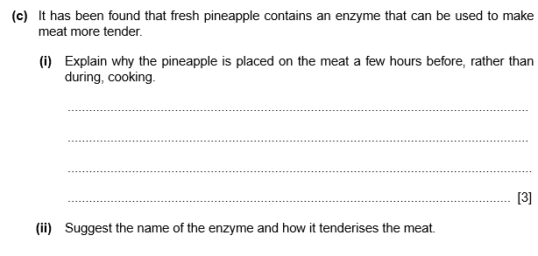

Q What are catalysts?Why are enzymes known as Biological Catalyst?

Q What amount of catalyst is consumed in the reaction it catalyzes?
Q Discuss the importace of enzymes in our daily lives.

Q What is the activation center of an enzyme? Is it the key or the lock in the lock and key model?

Q Describe the main factors that alter the speed of enzymatic reactions?

Q Explain, with reasons and examples, how the biological activity of an enzyme may be affected by:
a. changes in pH; and
b. increasing temperatures.

Q Discuss the characteristics of enzymes.
Q Describe the major properties of enzymes.
Q Discuss the mode of action of an enzyme in terms of active site, enzyme-substrate complex, activation energy and enzyme specificity.

Q Look at the graph and answer the following questions:
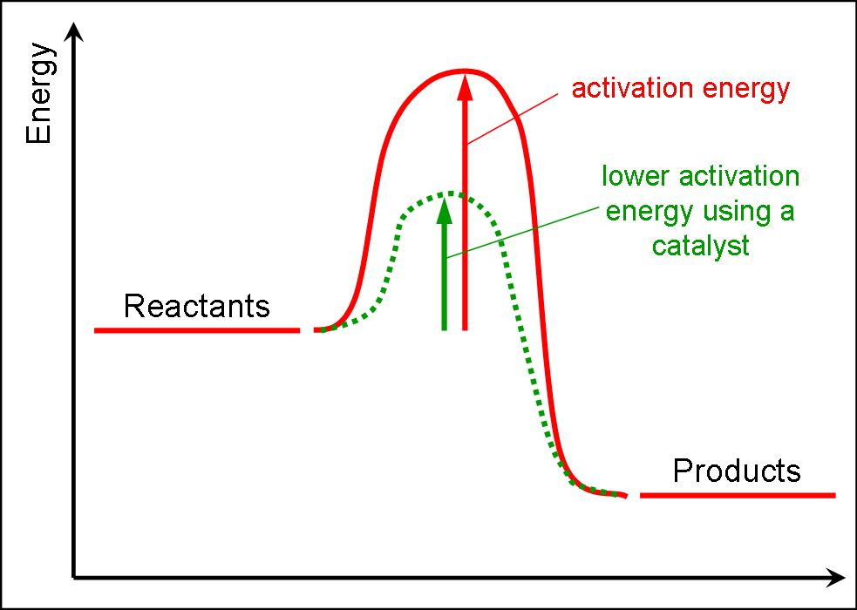
- Define Activation energy.
- Explain how does an enzyme lower the activation energy?

Q look at the graph and answer the following questions:

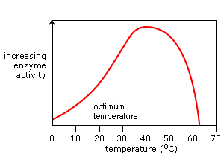
- Which temperature shows the best activity of enzyme?
- Explain your answer of part I
- Why does enzyme activity decline after 40 C?

