BLOG WORKSHEET
BIOLOGY CLASS 10

Teacher Name: Uzma Amer Class: 10 Biology Date: 12th jan’18

Q.1. Choose the best answers:
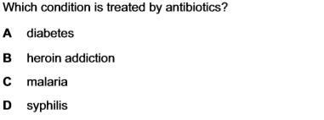

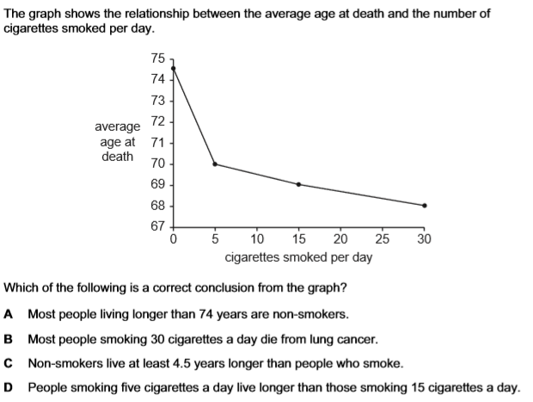

Q.2.
- what is antibiotic?
- Describe large scale production of a named antibiotic.
- Explain the advantages and the danger of using antibiotics
- Describe the dangers of heroin abuse.

