BLOG WORKSHEET
BIOLOGY CLASS 9

Teacher Name: Uzma Amer Class: 9 Biology Date: 12th jan’18
Q.1 Choose the best answer:
- Raw materials for photosynthesis include
- light
- organic substances
- nutrients
- all of these
Answer D
- Chlorophyll is found in oval-shaped structures called as
- stomata
- stoma
- chloroplast
- centrioles
Answer C
- To form one glucose molecule (C₆H₁₂O₆), number of water molecules required are
- six
- eight
- ten
- twelve
- photosynthesis takes place when
- CO2 and water is provided to the plant
- When sunlight is there
- Chlorophyll is present in the leaf
- All of above

- z

- Answer D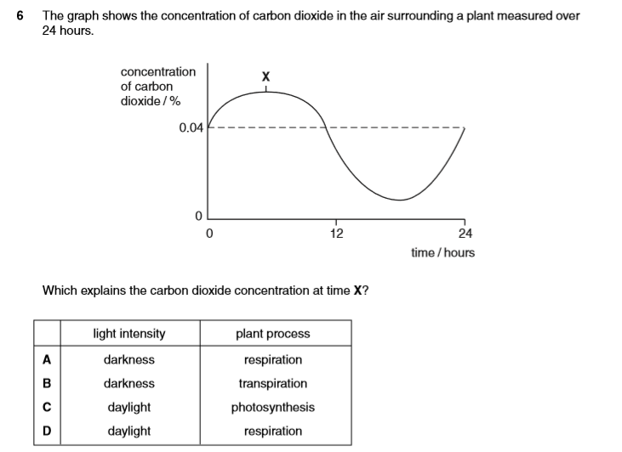
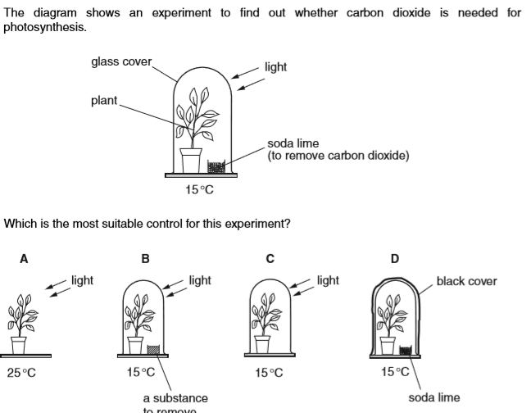
Qqqq

QqqQqbb
Q

