BLOG WORKSHEET
BIOLOGY CLASS 9

Teacher Name: Uzma Amer Class: 9 Biology Date: 9th feb’18
Q.1 Choose the best answer:
- The diagram refers to some substances found in plant cells.

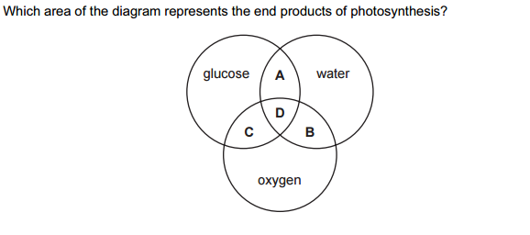
- Sugar moves in phloem vessels as ______.
- Cellulose
- Glucose
- Starch
- sucrose

- During light phase of photosynthesis ______ is oxidized and ______ is reduced.
- CO2 and Water
- Water and CO2
- Water and NADP
- NADPH2 and CO2
- Rapid diffusion of carbon dioxide (CO2) to inner cells is ensured through
- large flat surface
- leaf stalk
- thin lamina
- closely packed palisade cells
- Leaf stalk enables in
- rapid diffusion of carbon dioxide
- rapid diffusion of maximum sunlight
- rapid loss of water
- rapid conversion of physical energy in chemical energy
- More light can be absorbed near leaf surface due to
- more chloroplast in upper epidermis
- more chloroplast in lower epidermis
- more chloroplasts in stomata
- more chloroplasts in upper palisade tissues

- Which organelle of the leaf reflects back excess light?

  - Stomata
  - Guard cells
  - Waxy cuticle
  - Midrib
- Which is the chemical equation for photosynthesis in plants?
A. C6H12O6 + 6O2 + ATP → 6CO2 + 6H2O
B. 6CO2 + 6H2O + light → C6H12O6 + 6O2 + 6H2O
C. C6H12O6 + 6O2 → 6CO2 + 6H2O + energy

Q.2. Look at the diagram and answer the following questions:
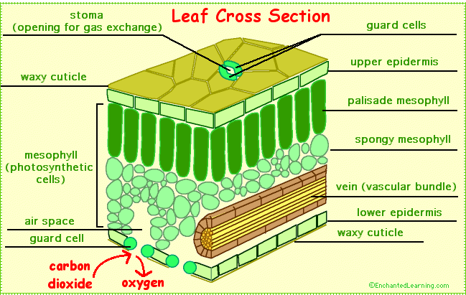

- Which layer of the leaf has the most chlorophyll?
- What is the function of upper epidermis?
- Why do spongy mesophyll have air spaces?

