Self-assessment questions 19.01

The City School
North Nazimabad boys campus
Biology Reinforcement Worksheet Grade 11
Name: _____________________________ Section: ______Date: __________

Co-ordination

1 Name the two systems which help to co-ordinate the body's actions.

2 Name the two structures which make up the central nervous system.

3 (a) The nerve fibres which carry impulses from the sense organs to the central nervous
system are called ….. A ….. fibres.
(b) The nerve fibres which carry impulses from the central nervous system to the glands and
muscles are called ….. B ….. fibres.

4 Complete the passage below, selecting the appropriate words from the list below.
A neurone (nerve cell) consists of a ….. A ….. containing a nucleus surrounded by
….. B ….. Branching filaments, called ….. C ….., extend from the cell surface and make
….. D ….., with other neurones. In ….. E ….. and ….. F ….. neurones, one of the filaments is
very long and is called ,,,,, G …..

sensory, nerve fibre, cell body, impulses, dendrons, dendrites, motor, contact, axons,
synapses, cytoplasm

5 Which one of the following is the most likely speed of conduction of a nerve impulse?
10 metres per second
50 metres per second
1000 metres per second.

6 Which one of the following best explains how we can tell which part of the body a sensory
nerve impulse comes from?
(a) Impulses from each part of the body are different.
(b) Each part of the body is connected to its own region of the brain.
(c) Sensations of touch, heat, light etc. are carried by nerve fibres to the brain.
(d) We learn from experience where the impulses come from.
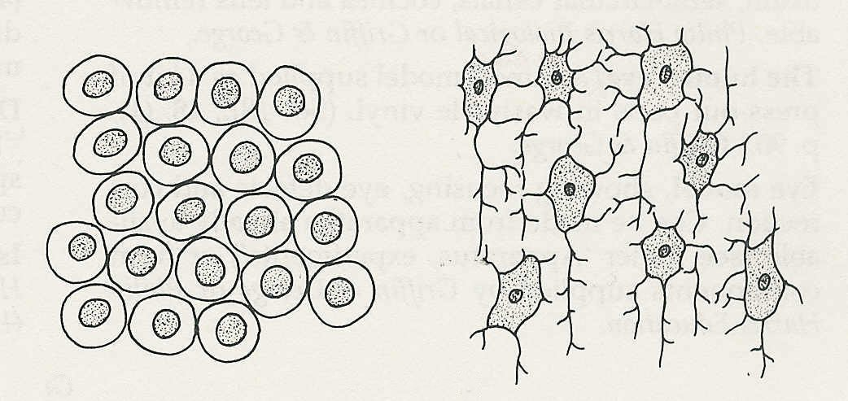
7 A transverse section through the spinal
cord is examined under the high power of
the microscope. Part of it looks like diagram
A and part looks like diagram B. Which is
grey matter and which is white matter?
Give reasons for your decision.
A
(not to same scale)
B

8 Give three examples of reflex actions.

9 Complete the passage below, selecting the most appropriate words from the list below.
In a spinal reflex a …..A …..is stimulated to produce a nerve impulse which travels
in a ….. B ….. fibre to the ….. C ….. Here, the nerve fibre makes a …..D ….. with a
relay (association) …… E …..which transmits the impulse to a ….. F ….. fibre. This fibre conducts the impulse to an …..G ….. organ such as muscle.

effector, tendon, sensory, sense organ, motor, nerve, brain, spinal cord, active,
synapse, neurone

Co-ordination (continued)
Self-assessment questions 19.02

10 In a reflex knee-jerk, what is (a) the receptor, (b) the effector?

11 Match the following structures and functions of the brain.
(a) Cerebellum. (i) Memory and reasoning.
(b) Medulla. (ii) Balance and muscular co-ordination.
(c) Cerebral hemisphere (iii) Control of heart beat and breathing.
(d) Mid-brain. (iv) Eye movements.

12 In the table below, enter some general points of contrast between the nervous and.
endocrine systems.

 | Nervous system | Endocrine system
Speed of conduction
Route of conduction
Area affected
Duration of response

13 Which one of the following statements about adrenaline is correct?
(a) It increases heart rate and increases release of glucose from the liver.
(b) It increases heart rate and reduces release of glucose from the liver.
(c) It reduces heart rate and increases release of glucose from the liver.
(d) It reduces heart rate and reduces release of glucose from the liver.

14 Name the two hormones produced by the pancreas and say (a) in what circumstances,
(b) in what way, they adjust the glucose concentration in the blood.

15 Name the hormones produced by (a) the testes, (b) the ovaries.

16 (a) Name the condition and
(b) describe the effects of the failure of the pancreas to produce sufficient-insulin.
(c) How is this condition treated? .

17 The pituitary gland produces several hormones, including ADH, FSH, LH and TSH. Give the full name of each of these hormones and say briefly what each one does.

