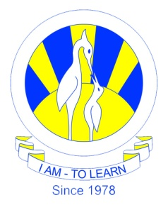
The City School
North Nazimabad Boys Campus
BIOLOGY SYLLABUS OF
2ND MONTHLY ASSESSMENT FINAL TERM 2017
Date: 02-03-2017
Subject: Biology
Class: 10
Teacher: Humaira Imran

1.SMOKING
2.MICRO ORGANISM AND BIOTECHNOLOGY
.VIRUS
.BACTERIA

