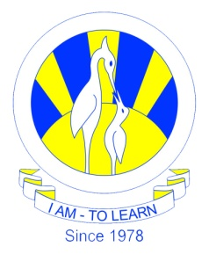
The City School
North Nazimabad Boys Campus
BIOLOGY SYLLABUS OF
2ND MONTHLY ASSESSMENT FINAL TERM 2017
Date: 02-03-2017
Subject: Biology
Class: 11
Teacher: Humaira Imran

1.DRUGS
2.EXCRETION
3.ENDOCRINE SYSTEM
4.NERVOUS SYSTEM

